**Emergency Responder Radio System**

**Coverage Report Test Results**

|  |  |
| --- | --- |
| **Date Prepared:** | Mar 13, 2025 |
| **Test File:** | SEA 2025 Garage1 |
| **Test Location:** | SEA Garage (Noise Floor) |
|  |  |
| **Technician:** | Aaron Keyte |
| **FCC#:** | PG00066071 |

**Building: SEA Garage (Noise Floor)**

**Result: Pass**

**Test Report Summary**

| **Channel/ Ch Group** | **Freq (MHz)** | **Technology** | **Band** | **Result** | **Area Points**  **passed (%)** | **Critical Points passed (%)** |
| --- | --- | --- | --- | --- | --- | --- |
| 5 | 854.66250 | P25 | SeaTac 2025 | Pass | 555/555 (100%) | 88/88 (100%) |

|  |  |  |  |
| --- | --- | --- | --- |
| **Test Details** | | | |
| **Number of Floors Tested:** | 5 | **Result Calculation:** | By area per floor |
| **Number of Areas Tested:** | 555 | **Area Pass Criteria:** | 95% |
| **Number of Critical Points Tested:** | 88 | **Critical Points Pass Criteria:** | 99% |
|  |  | **Apply Adjacent Area Rule:** | Yes |

|  |  |  |  |  |
| --- | --- | --- | --- | --- |
| **Equipment Configuration** | | | | |
| **Vendor**  PCTEL  Motorola | **Application** | **Device** | **Calibration Expires** | **Antenna info** |
| SeeHawk Touch  rel 3.2.0.2 | SeeGull IBflex Device rel 3.10.0.0  SN: 081911044 | 2-13-2026 | Ant1:Motorola V/U/700/800 |
| NA | Portable Radio | NA | Model: TBD SN: TBD |
| Motorola | NA | Portable Radio | NA | Model: TBD SN: TBD |

**Threshold Settings**

| **Measurement** | **DL Area Point** | **UL Area Point** | **DL Critical Point** | **UL Critical Point** | **Use for grading** |
| --- | --- | --- | --- | --- | --- |
| P25 Power (RSSI) | -150.0 dBm | -95.0 dBm | -150.0 dBm | -95.0 dBm | Yes |
| P25 S/N (SINR) | 16.0 dB | 16.0 dB | 16.0 dB | 16.0 dB | No |
| P25 FBER | 2.6 % | 2.6 % | 2.6 % | 2.6 % | No |
| DAQ | 3.4 |  |  |  | No |

**Floors Result**

| **Floor Plan** | **5 854.66250** |
| --- | --- |
| Garage L1 | **Pass** |
| Garage L2 | **Pass** |
| Garage L3 | **Pass** |
| Garage L4 | **Pass** |
| Garage L5 | **Pass** |

**Floor: Garage L1**

**Channel: 5**

**Result: Pass**

| **Freq (MHz)** | **Tech** | **Band** | **Ant Gain** | **Cable Loss** | **Ph.** | **Type** | **Mod** | **NAC** | **Area Points passed (%)** | **Critical Points passed (%)** |
| --- | --- | --- | --- | --- | --- | --- | --- | --- | --- | --- |
| 854.66250 | P25 | SeaTac 2025 | 0.00 | 0.00 |  | TC |  |  | 113/113 (100%) | 16/16 (100%) |

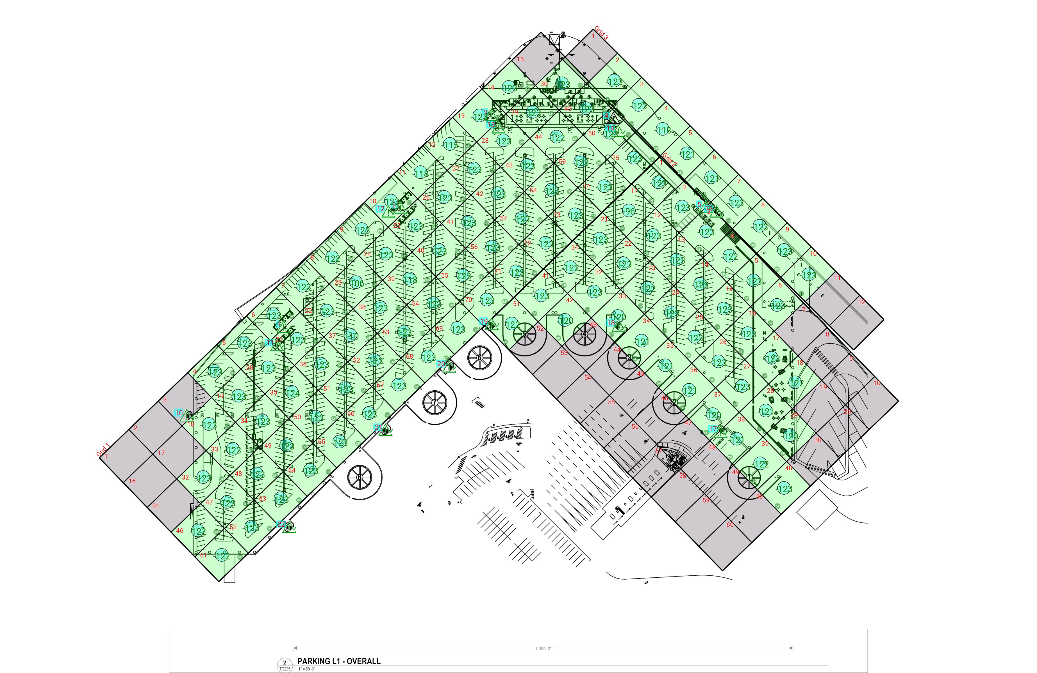

| **Grid** | **# of Areas** | **Area Size (sq. ft)** | **Area Width**  **(ft)** | **Area Height**  **(ft)** | **Ignore Area Color** | **Comments** |
| --- | --- | --- | --- | --- | --- | --- |
| 1 | 75 | 5690.19 | 82.14 | 69.28 | Black |  |
| 2 | 60 | 5628.18 | 68.58 | 82.07 | Black |  |
| 3 | 12 | 5958.26 | 68.81 | 86.59 | Black |  |

**Floor: Garage L1**

**Channel: 5**

| **Critical Point Report** | | | | | | | | | | | |
| --- | --- | --- | --- | --- | --- | --- | --- | --- | --- | --- | --- |
| **Critical Point** | **DL**  **Power**  **(dBm)** | **DL**  **S/N**  **(dB)** | **DL FBER (%)** | **DL**  **DAQ** | **UL**  **Power**  **(dBm)** | **UL**  **S/N**  **(dB)** | **UL FBER (%)** | **UL**  **DAQ** | **Result** | **DL**  **Loss**  **(dB)** | **Comment** |
| 1 | -123.07 |  |  |  |  |  |  |  | **Pass** |  |  |
| 2 | -122.39 |  |  |  |  |  |  |  | **Pass** |  |  |
| 3 | -122.51 |  |  |  |  |  |  |  | **Pass** |  |  |
| 4 |  |  |  |  |  |  |  |  |  |  | No Access |
| 5 | -122.42 |  |  |  |  |  |  |  | **Pass** |  |  |
| 10 | -120.66 |  |  |  |  |  |  |  | **Pass** |  |  |
| 11 | -123.10 |  |  |  |  |  |  |  | **Pass** |  |  |
| 12 | -122.62 |  |  |  |  |  |  |  | **Pass** |  |  |
| 13 | -122.39 |  |  |  |  |  |  |  | **Pass** |  |  |
| 14 | -122.41 |  |  |  |  |  |  |  | **Pass** |  |  |
| 15 | -122.63 |  |  |  |  |  |  |  | **Pass** |  |  |
| 17 | -121.62 |  |  |  |  |  |  |  | **Pass** |  |  |
| 18 | -121.60 |  |  |  |  |  |  |  | **Pass** |  |  |
| 19 | -119.12 |  |  |  |  |  |  |  | **Pass** |  |  |
| 20 | -122.56 |  |  |  |  |  |  |  | **Pass** |  |  |
| 21 | -122.26 |  |  |  |  |  |  |  | **Pass** |  |  |
| 22 | -121.45 |  |  |  |  |  |  |  | **Pass** |  |  |

| **Area Report** | | | | | | | | | | | | |
| --- | --- | --- | --- | --- | --- | --- | --- | --- | --- | --- | --- | --- |
| **Grid** | **Area** | **DL**  **Power**  **(dBm)** | **DL**  **S/N**  **(dB)** | **DL FBER (%)** | **DL**  **DAQ** | **UL**  **Power**  **(dBm)** | **UL**  **S/N**  **(dB)** | **UL FBER (%)** | **UL**  **DAQ** | **Result** | **DL**  **Loss**  **(dB)** | **Comment** |
| 1 | 1 | NT | NT | NT | NT | NT | NT | NT | NT | **NT** |  |  |
| 1 | 2 | NT | NT | NT | NT | NT | NT | NT | NT | **NT** |  |  |
| 1 | 3 | NT | NT | NT | NT | NT | NT | NT | NT | **NT** |  |  |
| 1 | 4 | -122.46 |  |  |  |  |  |  |  | **Pass** |  |  |
| 1 | 5 | -122.70 |  |  |  |  |  |  |  | **Pass** |  |  |
| 1 | 6 | -122.94 |  |  |  |  |  |  |  | **Pass** |  |  |
| 1 | 7 | -122.66 |  |  |  |  |  |  |  | **Pass** |  |  |
| 1 | 8 | -122.00 |  |  |  |  |  |  |  | **Pass** |  |  |
| 1 | 9 | -122.48 |  |  |  |  |  |  |  | **Pass** |  |  |
| 1 | 10 | -122.77 |  |  |  |  |  |  |  | **Pass** |  |  |
| 1 | 11 | -117.85 |  |  |  |  |  |  |  | **Pass** |  |  |
| 1 | 12 | -114.19 |  |  |  |  |  |  |  | **Pass** |  |  |
| 1 | 13 | -122.54 |  |  |  |  |  |  |  | **Pass** |  |  |
| 1 | 14 | -122.72 |  |  |  |  |  |  |  | **Pass** |  |  |
| 1 | 15 | NT | NT | NT | NT | NT | NT | NT | NT | **NT** |  |  |
| 1 | 16 | NT | NT | NT | NT | NT | NT | NT | NT | **NT** |  |  |
| 1 | 17 | NT | NT | NT | NT | NT | NT | NT | NT | **NT** |  |  |
| 1 | 18 | -122.18 |  |  |  |  |  |  |  | **Pass** |  |  |
| 1 | 19 | -122.83 |  |  |  |  |  |  |  | **Pass** |  |  |
| 1 | 20 | -122.39 |  |  |  |  |  |  |  | **Pass** |  |  |
| 1 | 21 | -122.69 |  |  |  |  |  |  |  | **Pass** |  |  |
| 1 | 22 | -122.55 |  |  |  |  |  |  |  | **Pass** |  |  |
| 1 | 23 | -105.02 |  |  |  |  |  |  |  | **Pass** |  |  |
| 1 | 24 | -122.66 |  |  |  |  |  |  |  | **Pass** |  |  |
| 1 | 25 | -122.56 |  |  |  |  |  |  |  | **Pass** |  |  |
| 1 | 26 | -122.49 |  |  |  |  |  |  |  | **Pass** |  |  |
| 1 | 27 | -122.62 |  |  |  |  |  |  |  | **Pass** |  |  |
| 1 | 28 | -122.57 |  |  |  |  |  |  |  | **Pass** |  |  |
| 1 | 29 | -122.69 |  |  |  |  |  |  |  | **Pass** |  |  |
| 1 | 30 | -122.70 |  |  |  |  |  |  |  | **Pass** |  |  |
| 1 | 31 | NT | NT | NT | NT | NT | NT | NT | NT | **NT** |  |  |
| 1 | 32 | -122.73 |  |  |  |  |  |  |  | **Pass** |  |  |
| 1 | 33 | -122.85 |  |  |  |  |  |  |  | **Pass** |  |  |
| 1 | 34 | -122.41 |  |  |  |  |  |  |  | **Pass** |  |  |
| 1 | 35 | -123.01 |  |  |  |  |  |  |  | **Pass** |  |  |
| 1 | 36 | -122.90 |  |  |  |  |  |  |  | **Pass** |  |  |
| 1 | 37 | -109.30 |  |  |  |  |  |  |  | **Pass** |  |  |
| 1 | 38 | -122.88 |  |  |  |  |  |  |  | **Pass** |  |  |
| 1 | 39 | -117.76 |  |  |  |  |  |  |  | **Pass** |  |  |
| 1 | 40 | -122.76 |  |  |  |  |  |  |  | **Pass** |  |  |
| 1 | 41 | -122.70 |  |  |  |  |  |  |  | **Pass** |  |  |
| 1 | 42 | -122.53 |  |  |  |  |  |  |  | **Pass** |  |  |
| 1 | 43 | -122.53 |  |  |  |  |  |  |  | **Pass** |  |  |
| 1 | 44 | -121.87 |  |  |  |  |  |  |  | **Pass** |  |  |
| 1 | 45 | -122.55 |  |  |  |  |  |  |  | **Pass** |  |  |
| 1 | 46 | -121.26 |  |  |  |  |  |  |  | **Pass** |  |  |
| 1 | 47 | -122.25 |  |  |  |  |  |  |  | **Pass** |  |  |
| 1 | 48 | -122.91 |  |  |  |  |  |  |  | **Pass** |  |  |
| 1 | 49 | -122.93 |  |  |  |  |  |  |  | **Pass** |  |  |
| 1 | 50 | -122.72 |  |  |  |  |  |  |  | **Pass** |  |  |
| 1 | 51 | -122.89 |  |  |  |  |  |  |  | **Pass** |  |  |
| 1 | 52 | -122.27 |  |  |  |  |  |  |  | **Pass** |  |  |
| 1 | 53 | -122.86 |  |  |  |  |  |  |  | **Pass** |  |  |
| 1 | 54 | -122.55 |  |  |  |  |  |  |  | **Pass** |  |  |
| 1 | 55 | -122.70 |  |  |  |  |  |  |  | **Pass** |  |  |
| 1 | 56 | -122.39 |  |  |  |  |  |  |  | **Pass** |  |  |
| 1 | 57 | -122.58 |  |  |  |  |  |  |  | **Pass** |  |  |
| 1 | 58 | -122.48 |  |  |  |  |  |  |  | **Pass** |  |  |
| 1 | 59 | -122.58 |  |  |  |  |  |  |  | **Pass** |  |  |
| 1 | 60 | -122.36 |  |  |  |  |  |  |  | **Pass** |  |  |
| 1 | 61 | -121.37 |  |  |  |  |  |  |  | **Pass** |  |  |
| 1 | 62 | -122.74 |  |  |  |  |  |  |  | **Pass** |  |  |
| 1 | 63 | -122.67 |  |  |  |  |  |  |  | **Pass** |  |  |
| 1 | 64 | -122.91 |  |  |  |  |  |  |  | **Pass** |  |  |
| 1 | 65 | -122.89 |  |  |  |  |  |  |  | **Pass** |  |  |
| 1 | 66 | -122.71 |  |  |  |  |  |  |  | **Pass** |  |  |
| 1 | 67 | -122.54 |  |  |  |  |  |  |  | **Pass** |  |  |
| 1 | 68 | -122.19 |  |  |  |  |  |  |  | **Pass** |  |  |
| 1 | 69 | -122.60 |  |  |  |  |  |  |  | **Pass** |  |  |
| 1 | 70 | -122.56 |  |  |  |  |  |  |  | **Pass** |  |  |
| 1 | 71 | -122.44 |  |  |  |  |  |  |  | **Pass** |  |  |
| 1 | 72 | -122.55 |  |  |  |  |  |  |  | **Pass** |  |  |
| 1 | 73 | -122.48 |  |  |  |  |  |  |  | **Pass** |  |  |
| 1 | 74 | -122.53 |  |  |  |  |  |  |  | **Pass** |  |  |
| 1 | 75 | -122.62 |  |  |  |  |  |  |  | **Pass** |  |  |
| 2 | 1 | -122.64 |  |  |  |  |  |  |  | **Pass** |  |  |
| 2 | 2 | -122.59 |  |  |  |  |  |  |  | **Pass** |  |  |
| 2 | 3 | -122.36 |  |  |  |  |  |  |  | **Pass** |  |  |
| 2 | 4 | -121.62 |  |  |  |  |  |  |  | **Pass** |  |  |
| 2 | 5 | -122.20 |  |  |  |  |  |  |  | **Pass** |  |  |
| 2 | 6 | -122.72 |  |  |  |  |  |  |  | **Pass** |  |  |
| 2 | 7 | NT | NT | NT | NT | NT | NT | NT | NT | **NT** |  |  |
| 2 | 8 | NT | NT | NT | NT | NT | NT | NT | NT | **NT** |  |  |
| 2 | 9 | NT | NT | NT | NT | NT | NT | NT | NT | **NT** |  |  |
| 2 | 10 | NT | NT | NT | NT | NT | NT | NT | NT | **NT** |  |  |
| 2 | 11 | -95.43 |  |  |  |  |  |  |  | **Pass** |  |  |
| 2 | 12 | -122.66 |  |  |  |  |  |  |  | **Pass** |  |  |
| 2 | 13 | -122.46 |  |  |  |  |  |  |  | **Pass** |  |  |
| 2 | 14 | -122.68 |  |  |  |  |  |  |  | **Pass** |  |  |
| 2 | 15 | -122.56 |  |  |  |  |  |  |  | **Pass** |  |  |
| 2 | 16 | -122.57 |  |  |  |  |  |  |  | **Pass** |  |  |
| 2 | 17 | -122.42 |  |  |  |  |  |  |  | **Pass** |  |  |
| 2 | 18 | -121.76 |  |  |  |  |  |  |  | **Pass** |  |  |
| 2 | 19 | NT | NT | NT | NT | NT | NT | NT | NT | **NT** |  |  |
| 2 | 20 | NT | NT | NT | NT | NT | NT | NT | NT | **NT** |  |  |
| 2 | 21 | -122.44 |  |  |  |  |  |  |  | **Pass** |  |  |
| 2 | 22 | -122.11 |  |  |  |  |  |  |  | **Pass** |  |  |
| 2 | 23 | -121.71 |  |  |  |  |  |  |  | **Pass** |  |  |
| 2 | 24 | -122.60 |  |  |  |  |  |  |  | **Pass** |  |  |
| 2 | 25 | -122.57 |  |  |  |  |  |  |  | **Pass** |  |  |
| 2 | 26 | -122.63 |  |  |  |  |  |  |  | **Pass** |  |  |
| 2 | 27 | -122.45 |  |  |  |  |  |  |  | **Pass** |  |  |
| 2 | 28 | -120.62 |  |  |  |  |  |  |  | **Pass** |  |  |
| 2 | 29 | -119.40 |  |  |  |  |  |  |  | **Pass** |  |  |
| 2 | 30 | NT | NT | NT | NT | NT | NT | NT | NT | **NT** |  |  |
| 2 | 31 | -121.56 |  |  |  |  |  |  |  | **Pass** |  |  |
| 2 | 32 | -122.58 |  |  |  |  |  |  |  | **Pass** |  |  |
| 2 | 33 | -119.83 |  |  |  |  |  |  |  | **Pass** |  |  |
| 2 | 34 | -120.32 |  |  |  |  |  |  |  | **Pass** |  |  |
| 2 | 35 | -120.41 |  |  |  |  |  |  |  | **Pass** |  |  |
| 2 | 36 | -120.01 |  |  |  |  |  |  |  | **Pass** |  |  |
| 2 | 37 | -119.73 |  |  |  |  |  |  |  | **Pass** |  |  |
| 2 | 38 | -120.62 |  |  |  |  |  |  |  | **Pass** |  |  |
| 2 | 39 | -121.90 |  |  |  |  |  |  |  | **Pass** |  |  |
| 2 | 40 | -122.63 |  |  |  |  |  |  |  | **Pass** |  |  |
| 2 | 41 | -122.30 |  |  |  |  |  |  |  | **Pass** |  |  |
| 2 | 42 | -119.82 |  |  |  |  |  |  |  | **Pass** |  |  |
| 2 | 43 | NT | NT | NT | NT | NT | NT | NT | NT | **NT** |  |  |
| 2 | 44 | NT | NT | NT | NT | NT | NT | NT | NT | **NT** |  |  |
| 2 | 45 | NT | NT | NT | NT | NT | NT | NT | NT | **NT** |  |  |
| 2 | 46 | NT | NT | NT | NT | NT | NT | NT | NT | **NT** |  |  |
| 2 | 47 | NT | NT | NT | NT | NT | NT | NT | NT | **NT** |  |  |
| 2 | 48 | NT | NT | NT | NT | NT | NT | NT | NT | **NT** |  |  |
| 2 | 49 | NT | NT | NT | NT | NT | NT | NT | NT | **NT** |  |  |
| 2 | 50 | NT | NT | NT | NT | NT | NT | NT | NT | **NT** |  |  |
| 2 | 51 | -121.66 |  |  |  |  |  |  |  | **Pass** |  |  |
| 2 | 52 | NT | NT | NT | NT | NT | NT | NT | NT | **NT** |  |  |
| 2 | 53 | NT | NT | NT | NT | NT | NT | NT | NT | **NT** |  |  |
| 2 | 54 | NT | NT | NT | NT | NT | NT | NT | NT | **NT** |  |  |
| 2 | 55 | NT | NT | NT | NT | NT | NT | NT | NT | **NT** |  |  |
| 2 | 56 | NT | NT | NT | NT | NT | NT | NT | NT | **NT** |  |  |
| 2 | 57 | NT | NT | NT | NT | NT | NT | NT | NT | **NT** |  |  |
| 2 | 58 | NT | NT | NT | NT | NT | NT | NT | NT | **NT** |  |  |
| 2 | 59 | NT | NT | NT | NT | NT | NT | NT | NT | **NT** |  |  |
| 2 | 60 | NT | NT | NT | NT | NT | NT | NT | NT | **NT** |  |  |
| 3 | 1 | NT | NT | NT | NT | NT | NT | NT | NT | **NT** |  |  |
| 3 | 2 | -122.57 |  |  |  |  |  |  |  | **Pass** |  |  |
| 3 | 3 | -122.51 |  |  |  |  |  |  |  | **Pass** |  |  |
| 3 | 4 | -117.58 |  |  |  |  |  |  |  | **Pass** |  |  |
| 3 | 5 | -120.60 |  |  |  |  |  |  |  | **Pass** |  |  |
| 3 | 6 | -120.51 |  |  |  |  |  |  |  | **Pass** |  |  |
| 3 | 7 | -122.32 |  |  |  |  |  |  |  | **Pass** |  |  |
| 3 | 8 | -122.75 |  |  |  |  |  |  |  | **Pass** |  |  |
| 3 | 9 | -122.59 |  |  |  |  |  |  |  | **Pass** |  |  |
| 3 | 10 | -122.74 |  |  |  |  |  |  |  | **Pass** |  |  |
| 3 | 11 | NT | NT | NT | NT | NT | NT | NT | NT | **NT** |  |  |
| 3 | 12 | NT | NT | NT | NT | NT | NT | NT | NT | **NT** |  |  |

**Floor: Garage L2**

**Channel: 5**

**Result: Pass**

| **Freq (MHz)** | **Tech** | **Band** | **Ant Gain** | **Cable Loss** | **Ph.** | **Type** | **Mod** | **NAC** | **Area Points passed (%)** | **Critical Points passed (%)** |
| --- | --- | --- | --- | --- | --- | --- | --- | --- | --- | --- |
| 854.66250 | P25 | SeaTac 2025 | 0.00 | 0.00 |  | TC |  |  | 109/109 (100%) | 15/15 (100%) |

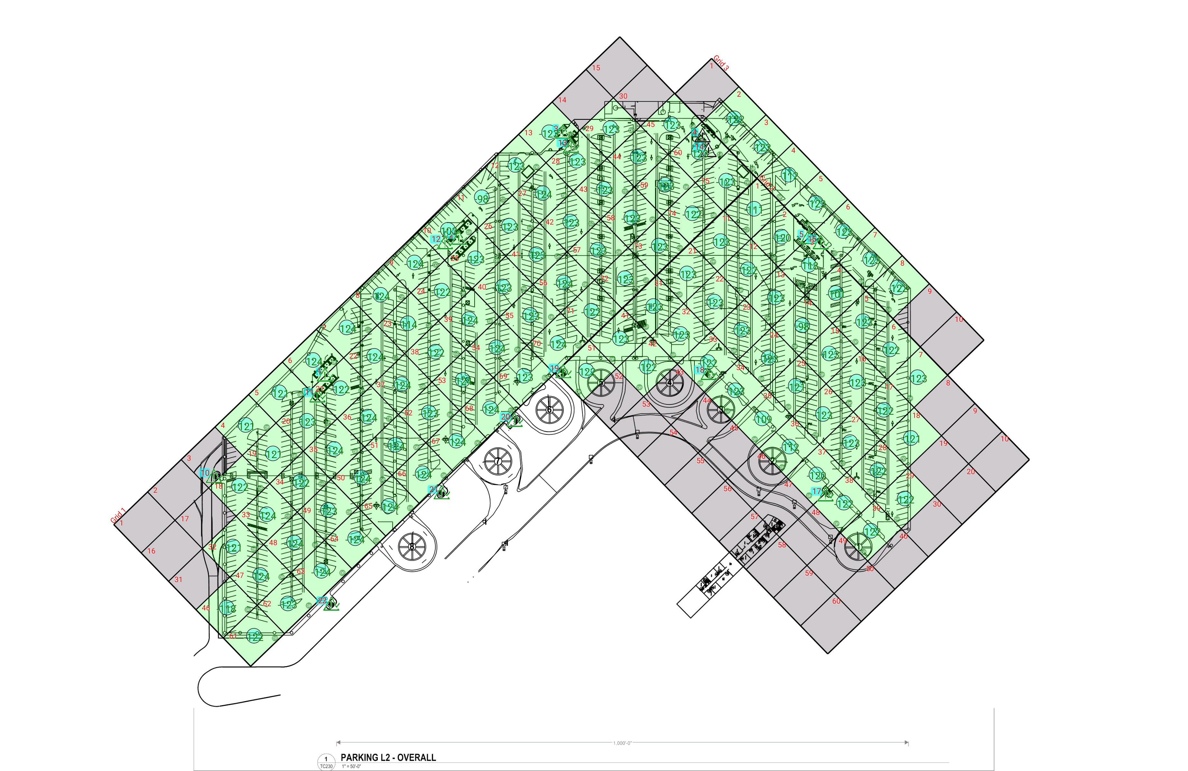

| **Grid** | **# of Areas** | **Area Size (sq. ft)** | **Area Width**  **(ft)** | **Area Height**  **(ft)** | **Ignore Area Color** | **Comments** |
| --- | --- | --- | --- | --- | --- | --- |
| 1 | 75 | 5681.15 | 82.18 | 69.13 | Black |  |
| 2 | 60 | 5619.36 | 68.61 | 81.90 | Black |  |
| 3 | 10 | 6117.10 | 68.72 | 89.02 | Black |  |

**Floor: Garage L2**

**Channel: 5**

| **Critical Point Report** | | | | | | | | | | | |
| --- | --- | --- | --- | --- | --- | --- | --- | --- | --- | --- | --- |
| **Critical Point** | **DL**  **Power**  **(dBm)** | **DL**  **S/N**  **(dB)** | **DL FBER (%)** | **DL**  **DAQ** | **UL**  **Power**  **(dBm)** | **UL**  **S/N**  **(dB)** | **UL FBER (%)** | **UL**  **DAQ** | **Result** | **DL**  **Loss**  **(dB)** | **Comment** |
| 1 | -123.71 |  |  |  |  |  |  |  | **Pass** |  |  |
| 2 | -122.54 |  |  |  |  |  |  |  | **Pass** |  |  |
| 3 | -122.06 |  |  |  |  |  |  |  | **Pass** |  |  |
| 4 |  |  |  |  |  |  |  |  |  |  | No Access |
| 5 | -121.98 |  |  |  |  |  |  |  | **Pass** |  |  |
| 10 | -117.69 |  |  |  |  |  |  |  | **Pass** |  |  |
| 11 | -118.22 |  |  |  |  |  |  |  | **Pass** |  |  |
| 12 | -122.46 |  |  |  |  |  |  |  | **Pass** |  |  |
| 13 | -122.96 |  |  |  |  |  |  |  | **Pass** |  |  |
| 14 |  |  |  |  |  |  |  |  |  |  | No Access |
| 15 | -121.56 |  |  |  |  |  |  |  | **Pass** |  |  |
| 17 | -120.92 |  |  |  |  |  |  |  | **Pass** |  |  |
| 18 | -113.05 |  |  |  |  |  |  |  | **Pass** |  |  |
| 19 | -122.78 |  |  |  |  |  |  |  | **Pass** |  |  |
| 20 | -123.16 |  |  |  |  |  |  |  | **Pass** |  |  |
| 21 | -123.22 |  |  |  |  |  |  |  | **Pass** |  |  |
| 22 | -118.00 |  |  |  |  |  |  |  | **Pass** |  |  |

| **Area Report** | | | | | | | | | | | | |
| --- | --- | --- | --- | --- | --- | --- | --- | --- | --- | --- | --- | --- |
| **Grid** | **Area** | **DL**  **Power**  **(dBm)** | **DL**  **S/N**  **(dB)** | **DL FBER (%)** | **DL**  **DAQ** | **UL**  **Power**  **(dBm)** | **UL**  **S/N**  **(dB)** | **UL FBER (%)** | **UL**  **DAQ** | **Result** | **DL**  **Loss**  **(dB)** | **Comment** |
| 1 | 1 | NT | NT | NT | NT | NT | NT | NT | NT | **NT** |  |  |
| 1 | 2 | NT | NT | NT | NT | NT | NT | NT | NT | **NT** |  |  |
| 1 | 3 | NT | NT | NT | NT | NT | NT | NT | NT | **NT** |  |  |
| 1 | 4 | -120.54 |  |  |  |  |  |  |  | **Pass** |  |  |
| 1 | 5 | -120.63 |  |  |  |  |  |  |  | **Pass** |  |  |
| 1 | 6 | -123.04 |  |  |  |  |  |  |  | **Pass** |  |  |
| 1 | 7 | -123.70 |  |  |  |  |  |  |  | **Pass** |  |  |
| 1 | 8 | -123.71 |  |  |  |  |  |  |  | **Pass** |  |  |
| 1 | 9 | -123.05 |  |  |  |  |  |  |  | **Pass** |  |  |
| 1 | 10 | -102.08 |  |  |  |  |  |  |  | **Pass** |  |  |
| 1 | 11 | -97.87 |  |  |  |  |  |  |  | **Pass** |  |  |
| 1 | 12 | -122.76 |  |  |  |  |  |  |  | **Pass** |  |  |
| 1 | 13 | -122.02 |  |  |  |  |  |  |  | **Pass** |  |  |
| 1 | 14 | NT | NT | NT | NT | NT | NT | NT | NT | **NT** |  |  |
| 1 | 15 | NT | NT | NT | NT | NT | NT | NT | NT | **NT** |  |  |
| 1 | 16 | NT | NT | NT | NT | NT | NT | NT | NT | **NT** |  |  |
| 1 | 17 | NT | NT | NT | NT | NT | NT | NT | NT | **NT** |  |  |
| 1 | 18 | -121.34 |  |  |  |  |  |  |  | **Pass** |  |  |
| 1 | 19 | -120.79 |  |  |  |  |  |  |  | **Pass** |  |  |
| 1 | 20 | -122.12 |  |  |  |  |  |  |  | **Pass** |  |  |
| 1 | 21 | -121.49 |  |  |  |  |  |  |  | **Pass** |  |  |
| 1 | 22 | -123.50 |  |  |  |  |  |  |  | **Pass** |  |  |
| 1 | 23 | -113.70 |  |  |  |  |  |  |  | **Pass** |  |  |
| 1 | 24 | -121.19 |  |  |  |  |  |  |  | **Pass** |  |  |
| 1 | 25 | -122.85 |  |  |  |  |  |  |  | **Pass** |  |  |
| 1 | 26 | -122.85 |  |  |  |  |  |  |  | **Pass** |  |  |
| 1 | 27 | -123.22 |  |  |  |  |  |  |  | **Pass** |  |  |
| 1 | 28 | -122.48 |  |  |  |  |  |  |  | **Pass** |  |  |
| 1 | 29 | -122.99 |  |  |  |  |  |  |  | **Pass** |  |  |
| 1 | 30 | NT | NT | NT | NT | NT | NT | NT | NT | **NT** |  |  |
| 1 | 31 | NT | NT | NT | NT | NT | NT | NT | NT | **NT** |  |  |
| 1 | 32 | -120.88 |  |  |  |  |  |  |  | **Pass** |  |  |
| 1 | 33 | -123.07 |  |  |  |  |  |  |  | **Pass** |  |  |
| 1 | 34 | -121.95 |  |  |  |  |  |  |  | **Pass** |  |  |
| 1 | 35 | -123.73 |  |  |  |  |  |  |  | **Pass** |  |  |
| 1 | 36 | -123.47 |  |  |  |  |  |  |  | **Pass** |  |  |
| 1 | 37 | -123.65 |  |  |  |  |  |  |  | **Pass** |  |  |
| 1 | 38 | -121.01 |  |  |  |  |  |  |  | **Pass** |  |  |
| 1 | 39 | -123.06 |  |  |  |  |  |  |  | **Pass** |  |  |
| 1 | 40 | -122.91 |  |  |  |  |  |  |  | **Pass** |  |  |
| 1 | 41 | -122.76 |  |  |  |  |  |  |  | **Pass** |  |  |
| 1 | 42 | -123.00 |  |  |  |  |  |  |  | **Pass** |  |  |
| 1 | 43 | -122.89 |  |  |  |  |  |  |  | **Pass** |  |  |
| 1 | 44 | -122.45 |  |  |  |  |  |  |  | **Pass** |  |  |
| 1 | 45 | -122.32 |  |  |  |  |  |  |  | **Pass** |  |  |
| 1 | 46 | -117.86 |  |  |  |  |  |  |  | **Pass** |  |  |
| 1 | 47 | -123.20 |  |  |  |  |  |  |  | **Pass** |  |  |
| 1 | 48 | -123.30 |  |  |  |  |  |  |  | **Pass** |  |  |
| 1 | 49 | -122.72 |  |  |  |  |  |  |  | **Pass** |  |  |
| 1 | 50 | -123.65 |  |  |  |  |  |  |  | **Pass** |  |  |
| 1 | 51 | -123.75 |  |  |  |  |  |  |  | **Pass** |  |  |
| 1 | 52 | -122.80 |  |  |  |  |  |  |  | **Pass** |  |  |
| 1 | 53 | -123.47 |  |  |  |  |  |  |  | **Pass** |  |  |
| 1 | 54 | -123.02 |  |  |  |  |  |  |  | **Pass** |  |  |
| 1 | 55 | -122.85 |  |  |  |  |  |  |  | **Pass** |  |  |
| 1 | 56 | -123.06 |  |  |  |  |  |  |  | **Pass** |  |  |
| 1 | 57 | -122.45 |  |  |  |  |  |  |  | **Pass** |  |  |
| 1 | 58 | -122.75 |  |  |  |  |  |  |  | **Pass** |  |  |
| 1 | 59 | -122.37 |  |  |  |  |  |  |  | **Pass** |  |  |
| 1 | 60 | -122.82 |  |  |  |  |  |  |  | **Pass** |  |  |
| 1 | 61 | -121.37 |  |  |  |  |  |  |  | **Pass** |  |  |
| 1 | 62 | -122.63 |  |  |  |  |  |  |  | **Pass** |  |  |
| 1 | 63 | -123.62 |  |  |  |  |  |  |  | **Pass** |  |  |
| 1 | 64 | -123.57 |  |  |  |  |  |  |  | **Pass** |  |  |
| 1 | 65 | -123.21 |  |  |  |  |  |  |  | **Pass** |  |  |
| 1 | 66 | -123.64 |  |  |  |  |  |  |  | **Pass** |  |  |
| 1 | 67 | -123.11 |  |  |  |  |  |  |  | **Pass** |  |  |
| 1 | 68 | -123.26 |  |  |  |  |  |  |  | **Pass** |  |  |
| 1 | 69 | -122.73 |  |  |  |  |  |  |  | **Pass** |  |  |
| 1 | 70 | -123.02 |  |  |  |  |  |  |  | **Pass** |  |  |
| 1 | 71 | -121.59 |  |  |  |  |  |  |  | **Pass** |  |  |
| 1 | 72 | -122.74 |  |  |  |  |  |  |  | **Pass** |  |  |
| 1 | 73 | -122.16 |  |  |  |  |  |  |  | **Pass** |  |  |
| 1 | 74 | -121.92 |  |  |  |  |  |  |  | **Pass** |  |  |
| 1 | 75 | -122.55 |  |  |  |  |  |  |  | **Pass** |  |  |
| 2 | 1 | -110.34 |  |  |  |  |  |  |  | **Pass** |  |  |
| 2 | 2 | -119.92 |  |  |  |  |  |  |  | **Pass** |  |  |
| 2 | 3 | -117.74 |  |  |  |  |  |  |  | **Pass** |  |  |
| 2 | 4 | -100.11 |  |  |  |  |  |  |  | **Pass** |  |  |
| 2 | 5 | -122.45 |  |  |  |  |  |  |  | **Pass** |  |  |
| 2 | 6 | -121.13 |  |  |  |  |  |  |  | **Pass** |  |  |
| 2 | 7 | -122.49 |  |  |  |  |  |  |  | **Pass** |  |  |
| 2 | 8 | NT | NT | NT | NT | NT | NT | NT | NT | **NT** |  |  |
| 2 | 9 | NT | NT | NT | NT | NT | NT | NT | NT | **NT** |  |  |
| 2 | 10 | NT | NT | NT | NT | NT | NT | NT | NT | **NT** |  |  |
| 2 | 11 | -122.68 |  |  |  |  |  |  |  | **Pass** |  |  |
| 2 | 12 | -121.33 |  |  |  |  |  |  |  | **Pass** |  |  |
| 2 | 13 | -122.21 |  |  |  |  |  |  |  | **Pass** |  |  |
| 2 | 14 | -97.73 |  |  |  |  |  |  |  | **Pass** |  |  |
| 2 | 15 | -122.67 |  |  |  |  |  |  |  | **Pass** |  |  |
| 2 | 16 | -122.49 |  |  |  |  |  |  |  | **Pass** |  |  |
| 2 | 17 | -121.79 |  |  |  |  |  |  |  | **Pass** |  |  |
| 2 | 18 | -120.01 |  |  |  |  |  |  |  | **Pass** |  |  |
| 2 | 19 | NT | NT | NT | NT | NT | NT | NT | NT | **NT** |  |  |
| 2 | 20 | NT | NT | NT | NT | NT | NT | NT | NT | **NT** |  |  |
| 2 | 21 | -122.90 |  |  |  |  |  |  |  | **Pass** |  |  |
| 2 | 22 | -122.69 |  |  |  |  |  |  |  | **Pass** |  |  |
| 2 | 23 | -122.62 |  |  |  |  |  |  |  | **Pass** |  |  |
| 2 | 24 | -122.23 |  |  |  |  |  |  |  | **Pass** |  |  |
| 2 | 25 | -120.50 |  |  |  |  |  |  |  | **Pass** |  |  |
| 2 | 26 | -122.62 |  |  |  |  |  |  |  | **Pass** |  |  |
| 2 | 27 | -122.12 |  |  |  |  |  |  |  | **Pass** |  |  |
| 2 | 28 | -121.88 |  |  |  |  |  |  |  | **Pass** |  |  |
| 2 | 29 | -121.84 |  |  |  |  |  |  |  | **Pass** |  |  |
| 2 | 30 | NT | NT | NT | NT | NT | NT | NT | NT | **NT** |  |  |
| 2 | 31 | -122.15 |  |  |  |  |  |  |  | **Pass** |  |  |
| 2 | 32 | -122.76 |  |  |  |  |  |  |  | **Pass** |  |  |
| 2 | 33 | -121.33 |  |  |  |  |  |  |  | **Pass** |  |  |
| 2 | 34 | -122.01 |  |  |  |  |  |  |  | **Pass** |  |  |
| 2 | 35 | -108.13 |  |  |  |  |  |  |  | **Pass** |  |  |
| 2 | 36 | -111.56 |  |  |  |  |  |  |  | **Pass** |  |  |
| 2 | 37 | -119.28 |  |  |  |  |  |  |  | **Pass** |  |  |
| 2 | 38 | -121.55 |  |  |  |  |  |  |  | **Pass** |  |  |
| 2 | 39 | -121.56 |  |  |  |  |  |  |  | **Pass** |  |  |
| 2 | 40 | NT | NT | NT | NT | NT | NT | NT | NT | **NT** |  |  |
| 2 | 41 | -122.58 |  |  |  |  |  |  |  | **Pass** |  |  |
| 2 | 42 | -121.78 |  |  |  |  |  |  |  | **Pass** |  |  |
| 2 | 43 | NT | NT | NT | NT | NT | NT | NT | NT | **NT** |  |  |
| 2 | 44 | NT | NT | NT | NT | NT | NT | NT | NT | **NT** |  |  |
| 2 | 45 | NT | NT | NT | NT | NT | NT | NT | NT | **NT** |  |  |
| 2 | 46 | NT | NT | NT | NT | NT | NT | NT | NT | **NT** |  |  |
| 2 | 47 | NT | NT | NT | NT | NT | NT | NT | NT | **NT** |  |  |
| 2 | 48 | NT | NT | NT | NT | NT | NT | NT | NT | **NT** |  |  |
| 2 | 49 | NT | NT | NT | NT | NT | NT | NT | NT | **NT** |  |  |
| 2 | 50 | NT | NT | NT | NT | NT | NT | NT | NT | **NT** |  |  |
| 2 | 51 | -121.84 |  |  |  |  |  |  |  | **Pass** |  |  |
| 2 | 52 | NT | NT | NT | NT | NT | NT | NT | NT | **NT** |  |  |
| 2 | 53 | NT | NT | NT | NT | NT | NT | NT | NT | **NT** |  |  |
| 2 | 54 | NT | NT | NT | NT | NT | NT | NT | NT | **NT** |  |  |
| 2 | 55 | NT | NT | NT | NT | NT | NT | NT | NT | **NT** |  |  |
| 2 | 56 | NT | NT | NT | NT | NT | NT | NT | NT | **NT** |  |  |
| 2 | 57 | NT | NT | NT | NT | NT | NT | NT | NT | **NT** |  |  |
| 2 | 58 | NT | NT | NT | NT | NT | NT | NT | NT | **NT** |  |  |
| 2 | 59 | NT | NT | NT | NT | NT | NT | NT | NT | **NT** |  |  |
| 2 | 60 | NT | NT | NT | NT | NT | NT | NT | NT | **NT** |  |  |
| 3 | 1 | NT | NT | NT | NT | NT | NT | NT | NT | **NT** |  |  |
| 3 | 2 | -121.82 |  |  |  |  |  |  |  | **Pass** |  |  |
| 3 | 3 | -122.47 |  |  |  |  |  |  |  | **Pass** |  |  |
| 3 | 4 | -111.86 |  |  |  |  |  |  |  | **Pass** |  |  |
| 3 | 5 | -122.53 |  |  |  |  |  |  |  | **Pass** |  |  |
| 3 | 6 | -122.29 |  |  |  |  |  |  |  | **Pass** |  |  |
| 3 | 7 | -122.02 |  |  |  |  |  |  |  | **Pass** |  |  |
| 3 | 8 | -122.00 |  |  |  |  |  |  |  | **Pass** |  |  |
| 3 | 9 | NT | NT | NT | NT | NT | NT | NT | NT | **NT** |  |  |
| 3 | 10 | NT | NT | NT | NT | NT | NT | NT | NT | **NT** |  |  |

**Floor: Garage L3**

**Channel: 5**

**Result: Pass**

| **Freq (MHz)** | **Tech** | **Band** | **Ant Gain** | **Cable Loss** | **Ph.** | **Type** | **Mod** | **NAC** | **Area Points passed (%)** | **Critical Points passed (%)** |
| --- | --- | --- | --- | --- | --- | --- | --- | --- | --- | --- |
| 854.66250 | P25 | SeaTac 2025 | 0.00 | 0.00 |  | TC |  |  | 113/113 (100%) | 19/19 (100%) |

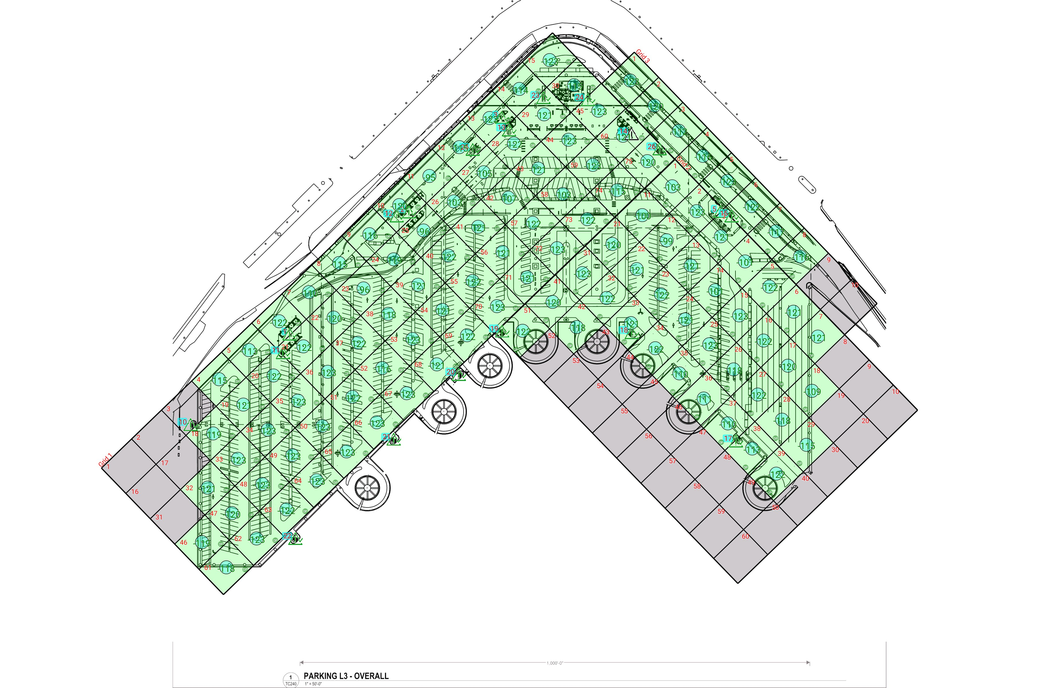

| **Grid** | **# of Areas** | **Area Size (sq. ft)** | **Area Width**  **(ft)** | **Area Height**  **(ft)** | **Ignore Area Color** | **Comments** |
| --- | --- | --- | --- | --- | --- | --- |
| 1 | 75 | 5725.85 | 82.50 | 69.40 | Black |  |
| 2 | 60 | 5663.54 | 68.88 | 82.22 | Black |  |
| 3 | 10 | 6165.19 | 68.99 | 89.37 | Black |  |

**Floor: Garage L3**

**Channel: 5**

| **Critical Point Report** | | | | | | | | | | | |
| --- | --- | --- | --- | --- | --- | --- | --- | --- | --- | --- | --- |
| **Critical Point** | **DL**  **Power**  **(dBm)** | **DL**  **S/N**  **(dB)** | **DL FBER (%)** | **DL**  **DAQ** | **UL**  **Power**  **(dBm)** | **UL**  **S/N**  **(dB)** | **UL FBER (%)** | **UL**  **DAQ** | **Result** | **DL**  **Loss**  **(dB)** | **Comment** |
| 1 | -120.96 |  |  |  |  |  |  |  | **Pass** |  |  |
| 2 | -118.43 |  |  |  |  |  |  |  | **Pass** |  |  |
| 3 | -122.32 |  |  |  |  |  |  |  | **Pass** |  |  |
| 5 | -122.27 |  |  |  |  |  |  |  | **Pass** |  |  |
| 10 | -115.74 |  |  |  |  |  |  |  | **Pass** |  |  |
| 11 | -122.57 |  |  |  |  |  |  |  | **Pass** |  |  |
| 12 | -119.79 |  |  |  |  |  |  |  | **Pass** |  |  |
| 13 | -121.61 |  |  |  |  |  |  |  | **Pass** |  |  |
| 14 |  |  |  |  |  |  |  |  |  |  | No Access |
| 15 | -121.72 |  |  |  |  |  |  |  | **Pass** |  |  |
| 17 | -117.52 |  |  |  |  |  |  |  | **Pass** |  |  |
| 18 | -121.19 |  |  |  |  |  |  |  | **Pass** |  |  |
| 19 | -122.08 |  |  |  |  |  |  |  | **Pass** |  |  |
| 20 | -121.57 |  |  |  |  |  |  |  | **Pass** |  |  |
| 21 | -121.97 |  |  |  |  |  |  |  | **Pass** |  |  |
| 22 | -121.15 |  |  |  |  |  |  |  | **Pass** |  |  |
| 23 | -120.09 |  |  |  |  |  |  |  | **Pass** |  |  |
| 24 | -120.03 |  |  |  |  |  |  |  | **Pass** |  |  |
| 25 | -122.21 |  |  |  |  |  |  |  | **Pass** |  |  |
| 26 | -119.54 |  |  |  |  |  |  |  | **Pass** |  |  |

| **Area Report** | | | | | | | | | | | | |
| --- | --- | --- | --- | --- | --- | --- | --- | --- | --- | --- | --- | --- |
| **Grid** | **Area** | **DL**  **Power**  **(dBm)** | **DL**  **S/N**  **(dB)** | **DL FBER (%)** | **DL**  **DAQ** | **UL**  **Power**  **(dBm)** | **UL**  **S/N**  **(dB)** | **UL FBER (%)** | **UL**  **DAQ** | **Result** | **DL**  **Loss**  **(dB)** | **Comment** |
| 1 | 1 | NT | NT | NT | NT | NT | NT | NT | NT | **NT** |  |  |
| 1 | 2 | NT | NT | NT | NT | NT | NT | NT | NT | **NT** |  |  |
| 1 | 3 | NT | NT | NT | NT | NT | NT | NT | NT | **NT** |  |  |
| 1 | 4 | -114.81 |  |  |  |  |  |  |  | **Pass** |  |  |
| 1 | 5 | -112.53 |  |  |  |  |  |  |  | **Pass** |  |  |
| 1 | 6 | -121.86 |  |  |  |  |  |  |  | **Pass** |  |  |
| 1 | 7 | -109.87 |  |  |  |  |  |  |  | **Pass** |  |  |
| 1 | 8 | -114.02 |  |  |  |  |  |  |  | **Pass** |  |  |
| 1 | 9 | -115.55 |  |  |  |  |  |  |  | **Pass** |  |  |
| 1 | 10 | -119.05 |  |  |  |  |  |  |  | **Pass** |  |  |
| 1 | 11 | -94.66 |  |  |  |  |  |  |  | **Pass** |  |  |
| 1 | 12 | -114.91 |  |  |  |  |  |  |  | **Pass** |  |  |
| 1 | 13 | -122.37 |  |  |  |  |  |  |  | **Pass** |  |  |
| 1 | 14 | -113.15 |  |  |  |  |  |  |  | **Pass** |  |  |
| 1 | 15 | -122.36 |  |  |  |  |  |  |  | **Pass** |  |  |
| 1 | 16 | NT | NT | NT | NT | NT | NT | NT | NT | **NT** |  |  |
| 1 | 17 | NT | NT | NT | NT | NT | NT | NT | NT | **NT** |  |  |
| 1 | 18 | -118.89 |  |  |  |  |  |  |  | **Pass** |  |  |
| 1 | 19 | -120.04 |  |  |  |  |  |  |  | **Pass** |  |  |
| 1 | 20 | -121.39 |  |  |  |  |  |  |  | **Pass** |  |  |
| 1 | 21 | -121.53 |  |  |  |  |  |  |  | **Pass** |  |  |
| 1 | 22 | -119.05 |  |  |  |  |  |  |  | **Pass** |  |  |
| 1 | 23 | -95.01 |  |  |  |  |  |  |  | **Pass** |  |  |
| 1 | 24 | -118.48 |  |  |  |  |  |  |  | **Pass** |  |  |
| 1 | 25 | -95.39 |  |  |  |  |  |  |  | **Pass** |  |  |
| 1 | 26 | -102.32 |  |  |  |  |  |  |  | **Pass** |  |  |
| 1 | 27 | -104.12 |  |  |  |  |  |  |  | **Pass** |  |  |
| 1 | 28 | -121.05 |  |  |  |  |  |  |  | **Pass** |  |  |
| 1 | 29 | -120.65 |  |  |  |  |  |  |  | **Pass** |  |  |
| 1 | 30 | -114.10 |  |  |  |  |  |  |  | **Pass** |  |  |
| 1 | 31 | NT | NT | NT | NT | NT | NT | NT | NT | **NT** |  |  |
| 1 | 32 | -120.74 |  |  |  |  |  |  |  | **Pass** |  |  |
| 1 | 33 | -122.34 |  |  |  |  |  |  |  | **Pass** |  |  |
| 1 | 34 | -122.19 |  |  |  |  |  |  |  | **Pass** |  |  |
| 1 | 35 | -122.50 |  |  |  |  |  |  |  | **Pass** |  |  |
| 1 | 36 | -122.61 |  |  |  |  |  |  |  | **Pass** |  |  |
| 1 | 37 | -122.00 |  |  |  |  |  |  |  | **Pass** |  |  |
| 1 | 38 | -117.49 |  |  |  |  |  |  |  | **Pass** |  |  |
| 1 | 39 | -120.80 |  |  |  |  |  |  |  | **Pass** |  |  |
| 1 | 40 | -121.30 |  |  |  |  |  |  |  | **Pass** |  |  |
| 1 | 41 | -120.73 |  |  |  |  |  |  |  | **Pass** |  |  |
| 1 | 42 | -106.62 |  |  |  |  |  |  |  | **Pass** |  |  |
| 1 | 43 | -120.39 |  |  |  |  |  |  |  | **Pass** |  |  |
| 1 | 44 | -122.40 |  |  |  |  |  |  |  | **Pass** |  |  |
| 1 | 45 | -122.45 |  |  |  |  |  |  |  | **Pass** |  |  |
| 1 | 46 | -118.72 |  |  |  |  |  |  |  | **Pass** |  |  |
| 1 | 47 | -119.16 |  |  |  |  |  |  |  | **Pass** |  |  |
| 1 | 48 | -122.36 |  |  |  |  |  |  |  | **Pass** |  |  |
| 1 | 49 | -122.01 |  |  |  |  |  |  |  | **Pass** |  |  |
| 1 | 50 | -122.07 |  |  |  |  |  |  |  | **Pass** |  |  |
| 1 | 51 | -121.88 |  |  |  |  |  |  |  | **Pass** |  |  |
| 1 | 52 | -115.53 |  |  |  |  |  |  |  | **Pass** |  |  |
| 1 | 53 | -122.32 |  |  |  |  |  |  |  | **Pass** |  |  |
| 1 | 54 | -120.73 |  |  |  |  |  |  |  | **Pass** |  |  |
| 1 | 55 | -121.91 |  |  |  |  |  |  |  | **Pass** |  |  |
| 1 | 56 | -120.88 |  |  |  |  |  |  |  | **Pass** |  |  |
| 1 | 57 | -121.74 |  |  |  |  |  |  |  | **Pass** |  |  |
| 1 | 58 | -102.21 |  |  |  |  |  |  |  | **Pass** |  |  |
| 1 | 59 | -122.36 |  |  |  |  |  |  |  | **Pass** |  |  |
| 1 | 60 | -120.29 |  |  |  |  |  |  |  | **Pass** |  |  |
| 1 | 61 | -117.74 |  |  |  |  |  |  |  | **Pass** |  |  |
| 1 | 62 | -122.33 |  |  |  |  |  |  |  | **Pass** |  |  |
| 1 | 63 | -121.55 |  |  |  |  |  |  |  | **Pass** |  |  |
| 1 | 64 | -122.22 |  |  |  |  |  |  |  | **Pass** |  |  |
| 1 | 65 | -122.31 |  |  |  |  |  |  |  | **Pass** |  |  |
| 1 | 66 | -122.34 |  |  |  |  |  |  |  | **Pass** |  |  |
| 1 | 67 | -122.35 |  |  |  |  |  |  |  | **Pass** |  |  |
| 1 | 68 | -120.80 |  |  |  |  |  |  |  | **Pass** |  |  |
| 1 | 69 | -121.36 |  |  |  |  |  |  |  | **Pass** |  |  |
| 1 | 70 | -122.07 |  |  |  |  |  |  |  | **Pass** |  |  |
| 1 | 71 | -120.56 |  |  |  |  |  |  |  | **Pass** |  |  |
| 1 | 72 | -122.13 |  |  |  |  |  |  |  | **Pass** |  |  |
| 1 | 73 | -121.43 |  |  |  |  |  |  |  | **Pass** |  |  |
| 1 | 74 | -114.09 |  |  |  |  |  |  |  | **Pass** |  |  |
| 1 | 75 | -119.70 |  |  |  |  |  |  |  | **Pass** |  |  |
| 2 | 1 | -102.43 |  |  |  |  |  |  |  | **Pass** |  |  |
| 2 | 2 | -122.34 |  |  |  |  |  |  |  | **Pass** |  |  |
| 2 | 3 | -120.72 |  |  |  |  |  |  |  | **Pass** |  |  |
| 2 | 4 | -100.66 |  |  |  |  |  |  |  | **Pass** |  |  |
| 2 | 5 | -121.32 |  |  |  |  |  |  |  | **Pass** |  |  |
| 2 | 6 | -120.26 |  |  |  |  |  |  |  | **Pass** |  |  |
| 2 | 7 | -120.12 |  |  |  |  |  |  |  | **Pass** |  |  |
| 2 | 8 | NT | NT | NT | NT | NT | NT | NT | NT | **NT** |  |  |
| 2 | 9 | NT | NT | NT | NT | NT | NT | NT | NT | **NT** |  |  |
| 2 | 10 | NT | NT | NT | NT | NT | NT | NT | NT | **NT** |  |  |
| 2 | 11 | -99.34 |  |  |  |  |  |  |  | **Pass** |  |  |
| 2 | 12 | -98.83 |  |  |  |  |  |  |  | **Pass** |  |  |
| 2 | 13 | -120.81 |  |  |  |  |  |  |  | **Pass** |  |  |
| 2 | 14 | -100.98 |  |  |  |  |  |  |  | **Pass** |  |  |
| 2 | 15 | -122.09 |  |  |  |  |  |  |  | **Pass** |  |  |
| 2 | 16 | -121.78 |  |  |  |  |  |  |  | **Pass** |  |  |
| 2 | 17 | -119.08 |  |  |  |  |  |  |  | **Pass** |  |  |
| 2 | 18 | -108.31 |  |  |  |  |  |  |  | **Pass** |  |  |
| 2 | 19 | NT | NT | NT | NT | NT | NT | NT | NT | **NT** |  |  |
| 2 | 20 | NT | NT | NT | NT | NT | NT | NT | NT | **NT** |  |  |
| 2 | 21 | -119.64 |  |  |  |  |  |  |  | **Pass** |  |  |
| 2 | 22 | -120.65 |  |  |  |  |  |  |  | **Pass** |  |  |
| 2 | 23 | -121.12 |  |  |  |  |  |  |  | **Pass** |  |  |
| 2 | 24 | -120.91 |  |  |  |  |  |  |  | **Pass** |  |  |
| 2 | 25 | -122.06 |  |  |  |  |  |  |  | **Pass** |  |  |
| 2 | 26 | -117.91 |  |  |  |  |  |  |  | **Pass** |  |  |
| 2 | 27 | -121.85 |  |  |  |  |  |  |  | **Pass** |  |  |
| 2 | 28 | -117.63 |  |  |  |  |  |  |  | **Pass** |  |  |
| 2 | 29 | -114.93 |  |  |  |  |  |  |  | **Pass** |  |  |
| 2 | 30 | NT | NT | NT | NT | NT | NT | NT | NT | **NT** |  |  |
| 2 | 31 | -122.19 |  |  |  |  |  |  |  | **Pass** |  |  |
| 2 | 32 | -121.98 |  |  |  |  |  |  |  | **Pass** |  |  |
| 2 | 33 | -120.90 |  |  |  |  |  |  |  | **Pass** |  |  |
| 2 | 34 | -121.72 |  |  |  |  |  |  |  | **Pass** |  |  |
| 2 | 35 | -109.95 |  |  |  |  |  |  |  | **Pass** |  |  |
| 2 | 36 | -110.36 |  |  |  |  |  |  |  | **Pass** |  |  |
| 2 | 37 | -109.43 |  |  |  |  |  |  |  | **Pass** |  |  |
| 2 | 38 | -112.32 |  |  |  |  |  |  |  | **Pass** |  |  |
| 2 | 39 | -121.75 |  |  |  |  |  |  |  | **Pass** |  |  |
| 2 | 40 | NT | NT | NT | NT | NT | NT | NT | NT | **NT** |  |  |
| 2 | 41 | -119.05 |  |  |  |  |  |  |  | **Pass** |  |  |
| 2 | 42 | -117.31 |  |  |  |  |  |  |  | **Pass** |  |  |
| 2 | 43 | NT | NT | NT | NT | NT | NT | NT | NT | **NT** |  |  |
| 2 | 44 | NT | NT | NT | NT | NT | NT | NT | NT | **NT** |  |  |
| 2 | 45 | NT | NT | NT | NT | NT | NT | NT | NT | **NT** |  |  |
| 2 | 46 | NT | NT | NT | NT | NT | NT | NT | NT | **NT** |  |  |
| 2 | 47 | NT | NT | NT | NT | NT | NT | NT | NT | **NT** |  |  |
| 2 | 48 | NT | NT | NT | NT | NT | NT | NT | NT | **NT** |  |  |
| 2 | 49 | NT | NT | NT | NT | NT | NT | NT | NT | **NT** |  |  |
| 2 | 50 | NT | NT | NT | NT | NT | NT | NT | NT | **NT** |  |  |
| 2 | 51 | -121.10 |  |  |  |  |  |  |  | **Pass** |  |  |
| 2 | 52 | NT | NT | NT | NT | NT | NT | NT | NT | **NT** |  |  |
| 2 | 53 | NT | NT | NT | NT | NT | NT | NT | NT | **NT** |  |  |
| 2 | 54 | NT | NT | NT | NT | NT | NT | NT | NT | **NT** |  |  |
| 2 | 55 | NT | NT | NT | NT | NT | NT | NT | NT | **NT** |  |  |
| 2 | 56 | NT | NT | NT | NT | NT | NT | NT | NT | **NT** |  |  |
| 2 | 57 | NT | NT | NT | NT | NT | NT | NT | NT | **NT** |  |  |
| 2 | 58 | NT | NT | NT | NT | NT | NT | NT | NT | **NT** |  |  |
| 2 | 59 | NT | NT | NT | NT | NT | NT | NT | NT | **NT** |  |  |
| 2 | 60 | NT | NT | NT | NT | NT | NT | NT | NT | **NT** |  |  |
| 3 | 1 | -122.31 |  |  |  |  |  |  |  | **Pass** |  |  |
| 3 | 2 | -119.46 |  |  |  |  |  |  |  | **Pass** |  |  |
| 3 | 3 | -111.41 |  |  |  |  |  |  |  | **Pass** |  |  |
| 3 | 4 | -115.40 |  |  |  |  |  |  |  | **Pass** |  |  |
| 3 | 5 | -122.10 |  |  |  |  |  |  |  | **Pass** |  |  |
| 3 | 6 | -121.01 |  |  |  |  |  |  |  | **Pass** |  |  |
| 3 | 7 | -116.13 |  |  |  |  |  |  |  | **Pass** |  |  |
| 3 | 8 | -115.61 |  |  |  |  |  |  |  | **Pass** |  |  |
| 3 | 9 | NT | NT | NT | NT | NT | NT | NT | NT | **NT** |  |  |
| 3 | 10 | NT | NT | NT | NT | NT | NT | NT | NT | **NT** |  |  |

**Floor: Garage L4**

**Channel: 5**

**Result: Pass**

| **Freq (MHz)** | **Tech** | **Band** | **Ant Gain** | **Cable Loss** | **Ph.** | **Type** | **Mod** | **NAC** | **Area Points passed (%)** | **Critical Points passed (%)** |
| --- | --- | --- | --- | --- | --- | --- | --- | --- | --- | --- |
| 854.66250 | P25 | SeaTac 2025 | 0.00 | 0.00 |  | TC |  |  | 106/106 (100%) | 21/21 (100%) |

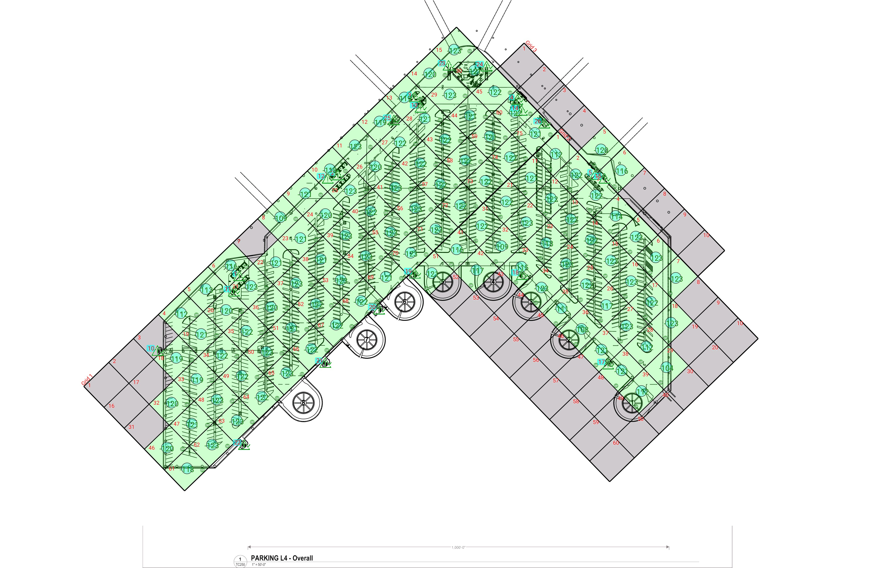

| **Grid** | **# of Areas** | **Area Size (sq. ft)** | **Area Width**  **(ft)** | **Area Height**  **(ft)** | **Ignore Area Color** | **Comments** |
| --- | --- | --- | --- | --- | --- | --- |
| 1 | 75 | 5723.66 | 82.57 | 69.32 | Black |  |
| 2 | 60 | 5661.29 | 68.94 | 82.13 | Black |  |
| 3 | 10 | 6162.60 | 69.04 | 89.26 | Black |  |

**Floor: Garage L4**

**Channel: 5**

| **Critical Point Report** | | | | | | | | | | | |
| --- | --- | --- | --- | --- | --- | --- | --- | --- | --- | --- | --- |
| **Critical Point** | **DL**  **Power**  **(dBm)** | **DL**  **S/N**  **(dB)** | **DL FBER (%)** | **DL**  **DAQ** | **UL**  **Power**  **(dBm)** | **UL**  **S/N**  **(dB)** | **UL FBER (%)** | **UL**  **DAQ** | **Result** | **DL**  **Loss**  **(dB)** | **Comment** |
| 1 | -121.60 |  |  |  |  |  |  |  | **Pass** |  |  |
| 2 | -122.49 |  |  |  |  |  |  |  | **Pass** |  |  |
| 3 | -119.85 |  |  |  |  |  |  |  | **Pass** |  |  |
| 4 | -122.86 |  |  |  |  |  |  |  | **Pass** |  |  |
| 5 | -120.88 |  |  |  |  |  |  |  | **Pass** |  |  |
| 10 | -119.17 |  |  |  |  |  |  |  | **Pass** |  |  |
| 11 | -121.05 |  |  |  |  |  |  |  | **Pass** |  |  |
| 12 | -121.67 |  |  |  |  |  |  |  | **Pass** |  |  |
| 13 | -122.36 |  |  |  |  |  |  |  | **Pass** |  |  |
| 14 | -122.14 |  |  |  |  |  |  |  | **Pass** |  |  |
| 15 | -121.72 |  |  |  |  |  |  |  | **Pass** |  |  |
| 17 | -105.60 |  |  |  |  |  |  |  | **Pass** |  |  |
| 18 | -109.98 |  |  |  |  |  |  |  | **Pass** |  |  |
| 19 | -122.44 |  |  |  |  |  |  |  | **Pass** |  |  |
| 20 | -121.91 |  |  |  |  |  |  |  | **Pass** |  |  |
| 21 | -121.32 |  |  |  |  |  |  |  | **Pass** |  |  |
| 22 | -121.85 |  |  |  |  |  |  |  | **Pass** |  |  |
| 23 | -117.09 |  |  |  |  |  |  |  | **Pass** |  |  |
| 24 | -119.33 |  |  |  |  |  |  |  | **Pass** |  |  |
| 25 | -118.86 |  |  |  |  |  |  |  | **Pass** |  |  |
| 26 | -120.01 |  |  |  |  |  |  |  | **Pass** |  |  |

| **Area Report** | | | | | | | | | | | | |
| --- | --- | --- | --- | --- | --- | --- | --- | --- | --- | --- | --- | --- |
| **Grid** | **Area** | **DL**  **Power**  **(dBm)** | **DL**  **S/N**  **(dB)** | **DL FBER (%)** | **DL**  **DAQ** | **UL**  **Power**  **(dBm)** | **UL**  **S/N**  **(dB)** | **UL FBER (%)** | **UL**  **DAQ** | **Result** | **DL**  **Loss**  **(dB)** | **Comment** |
| 1 | 1 | NT | NT | NT | NT | NT | NT | NT | NT | **NT** |  |  |
| 1 | 2 | NT | NT | NT | NT | NT | NT | NT | NT | **NT** |  |  |
| 1 | 3 | NT | NT | NT | NT | NT | NT | NT | NT | **NT** |  |  |
| 1 | 4 | -111.78 |  |  |  |  |  |  |  | **Pass** |  |  |
| 1 | 5 | -112.33 |  |  |  |  |  |  |  | **Pass** |  |  |
| 1 | 6 | -115.78 |  |  |  |  |  |  |  | **Pass** |  |  |
| 1 | 7 | NT | NT | NT | NT | NT | NT | NT | NT | **NT** |  |  |
| 1 | 8 | -108.73 |  |  |  |  |  |  |  | **Pass** |  |  |
| 1 | 9 | -120.33 |  |  |  |  |  |  |  | **Pass** |  |  |
| 1 | 10 | -117.30 |  |  |  |  |  |  |  | **Pass** |  |  |
| 1 | 11 | -122.77 |  |  |  |  |  |  |  | **Pass** |  |  |
| 1 | 12 | -118.84 |  |  |  |  |  |  |  | **Pass** |  |  |
| 1 | 13 | -118.89 |  |  |  |  |  |  |  | **Pass** |  |  |
| 1 | 14 | -119.43 |  |  |  |  |  |  |  | **Pass** |  |  |
| 1 | 15 | -122.56 |  |  |  |  |  |  |  | **Pass** |  |  |
| 1 | 16 | NT | NT | NT | NT | NT | NT | NT | NT | **NT** |  |  |
| 1 | 17 | NT | NT | NT | NT | NT | NT | NT | NT | **NT** |  |  |
| 1 | 18 | -118.69 |  |  |  |  |  |  |  | **Pass** |  |  |
| 1 | 19 | -120.54 |  |  |  |  |  |  |  | **Pass** |  |  |
| 1 | 20 | -119.61 |  |  |  |  |  |  |  | **Pass** |  |  |
| 1 | 21 | -122.40 |  |  |  |  |  |  |  | **Pass** |  |  |
| 1 | 22 | -120.05 |  |  |  |  |  |  |  | **Pass** |  |  |
| 1 | 23 | -120.75 |  |  |  |  |  |  |  | **Pass** |  |  |
| 1 | 24 | -119.98 |  |  |  |  |  |  |  | **Pass** |  |  |
| 1 | 25 | -122.66 |  |  |  |  |  |  |  | **Pass** |  |  |
| 1 | 26 | -119.30 |  |  |  |  |  |  |  | **Pass** |  |  |
| 1 | 27 | -121.77 |  |  |  |  |  |  |  | **Pass** |  |  |
| 1 | 28 | -120.63 |  |  |  |  |  |  |  | **Pass** |  |  |
| 1 | 29 | -122.05 |  |  |  |  |  |  |  | **Pass** |  |  |
| 1 | 30 | -120.05 |  |  |  |  |  |  |  | **Pass** |  |  |
| 1 | 31 | NT | NT | NT | NT | NT | NT | NT | NT | **NT** |  |  |
| 1 | 32 | -119.97 |  |  |  |  |  |  |  | **Pass** |  |  |
| 1 | 33 | -118.71 |  |  |  |  |  |  |  | **Pass** |  |  |
| 1 | 34 | -121.98 |  |  |  |  |  |  |  | **Pass** |  |  |
| 1 | 35 | -121.69 |  |  |  |  |  |  |  | **Pass** |  |  |
| 1 | 36 | -119.30 |  |  |  |  |  |  |  | **Pass** |  |  |
| 1 | 37 | -122.33 |  |  |  |  |  |  |  | **Pass** |  |  |
| 1 | 38 | -120.85 |  |  |  |  |  |  |  | **Pass** |  |  |
| 1 | 39 | -122.38 |  |  |  |  |  |  |  | **Pass** |  |  |
| 1 | 40 | -121.24 |  |  |  |  |  |  |  | **Pass** |  |  |
| 1 | 41 | -122.43 |  |  |  |  |  |  |  | **Pass** |  |  |
| 1 | 42 | -121.73 |  |  |  |  |  |  |  | **Pass** |  |  |
| 1 | 43 | -121.51 |  |  |  |  |  |  |  | **Pass** |  |  |
| 1 | 44 | -120.51 |  |  |  |  |  |  |  | **Pass** |  |  |
| 1 | 45 | -121.94 |  |  |  |  |  |  |  | **Pass** |  |  |
| 1 | 46 | -119.93 |  |  |  |  |  |  |  | **Pass** |  |  |
| 1 | 47 | -120.82 |  |  |  |  |  |  |  | **Pass** |  |  |
| 1 | 48 | -122.11 |  |  |  |  |  |  |  | **Pass** |  |  |
| 1 | 49 | -121.97 |  |  |  |  |  |  |  | **Pass** |  |  |
| 1 | 50 | -122.55 |  |  |  |  |  |  |  | **Pass** |  |  |
| 1 | 51 | -120.60 |  |  |  |  |  |  |  | **Pass** |  |  |
| 1 | 52 | -121.20 |  |  |  |  |  |  |  | **Pass** |  |  |
| 1 | 53 | -122.30 |  |  |  |  |  |  |  | **Pass** |  |  |
| 1 | 54 | -122.52 |  |  |  |  |  |  |  | **Pass** |  |  |
| 1 | 55 | -122.67 |  |  |  |  |  |  |  | **Pass** |  |  |
| 1 | 56 | -122.43 |  |  |  |  |  |  |  | **Pass** |  |  |
| 1 | 57 | -121.75 |  |  |  |  |  |  |  | **Pass** |  |  |
| 1 | 58 | -121.42 |  |  |  |  |  |  |  | **Pass** |  |  |
| 1 | 59 | -120.97 |  |  |  |  |  |  |  | **Pass** |  |  |
| 1 | 60 | -121.06 |  |  |  |  |  |  |  | **Pass** |  |  |
| 1 | 61 | -117.92 |  |  |  |  |  |  |  | **Pass** |  |  |
| 1 | 62 | -122.45 |  |  |  |  |  |  |  | **Pass** |  |  |
| 1 | 63 | -122.02 |  |  |  |  |  |  |  | **Pass** |  |  |
| 1 | 64 | -121.59 |  |  |  |  |  |  |  | **Pass** |  |  |
| 1 | 65 | -122.19 |  |  |  |  |  |  |  | **Pass** |  |  |
| 1 | 66 | -121.55 |  |  |  |  |  |  |  | **Pass** |  |  |
| 1 | 67 | -121.95 |  |  |  |  |  |  |  | **Pass** |  |  |
| 1 | 68 | -121.88 |  |  |  |  |  |  |  | **Pass** |  |  |
| 1 | 69 | -120.94 |  |  |  |  |  |  |  | **Pass** |  |  |
| 1 | 70 | -122.15 |  |  |  |  |  |  |  | **Pass** |  |  |
| 1 | 71 | -122.39 |  |  |  |  |  |  |  | **Pass** |  |  |
| 1 | 72 | -121.74 |  |  |  |  |  |  |  | **Pass** |  |  |
| 1 | 73 | -121.64 |  |  |  |  |  |  |  | **Pass** |  |  |
| 1 | 74 | -121.93 |  |  |  |  |  |  |  | **Pass** |  |  |
| 1 | 75 | -120.03 |  |  |  |  |  |  |  | **Pass** |  |  |
| 2 | 1 | -111.57 |  |  |  |  |  |  |  | **Pass** |  |  |
| 2 | 2 | -121.22 |  |  |  |  |  |  |  | **Pass** |  |  |
| 2 | 3 | -121.90 |  |  |  |  |  |  |  | **Pass** |  |  |
| 2 | 4 | -113.72 |  |  |  |  |  |  |  | **Pass** |  |  |
| 2 | 5 | -122.67 |  |  |  |  |  |  |  | **Pass** |  |  |
| 2 | 6 | -122.20 |  |  |  |  |  |  |  | **Pass** |  |  |
| 2 | 7 | -122.51 |  |  |  |  |  |  |  | **Pass** |  |  |
| 2 | 8 | NT | NT | NT | NT | NT | NT | NT | NT | **NT** |  |  |
| 2 | 9 | NT | NT | NT | NT | NT | NT | NT | NT | **NT** |  |  |
| 2 | 10 | NT | NT | NT | NT | NT | NT | NT | NT | **NT** |  |  |
| 2 | 11 | -120.45 |  |  |  |  |  |  |  | **Pass** |  |  |
| 2 | 12 | -121.72 |  |  |  |  |  |  |  | **Pass** |  |  |
| 2 | 13 | -121.66 |  |  |  |  |  |  |  | **Pass** |  |  |
| 2 | 14 | -121.09 |  |  |  |  |  |  |  | **Pass** |  |  |
| 2 | 15 | -122.04 |  |  |  |  |  |  |  | **Pass** |  |  |
| 2 | 16 | -122.56 |  |  |  |  |  |  |  | **Pass** |  |  |
| 2 | 17 | -121.98 |  |  |  |  |  |  |  | **Pass** |  |  |
| 2 | 18 | -122.52 |  |  |  |  |  |  |  | **Pass** |  |  |
| 2 | 19 | NT | NT | NT | NT | NT | NT | NT | NT | **NT** |  |  |
| 2 | 20 | NT | NT | NT | NT | NT | NT | NT | NT | **NT** |  |  |
| 2 | 21 | -121.45 |  |  |  |  |  |  |  | **Pass** |  |  |
| 2 | 22 | -122.20 |  |  |  |  |  |  |  | **Pass** |  |  |
| 2 | 23 | -117.09 |  |  |  |  |  |  |  | **Pass** |  |  |
| 2 | 24 | -122.35 |  |  |  |  |  |  |  | **Pass** |  |  |
| 2 | 25 | -121.68 |  |  |  |  |  |  |  | **Pass** |  |  |
| 2 | 26 | -116.88 |  |  |  |  |  |  |  | **Pass** |  |  |
| 2 | 27 | -122.94 |  |  |  |  |  |  |  | **Pass** |  |  |
| 2 | 28 | -111.47 |  |  |  |  |  |  |  | **Pass** |  |  |
| 2 | 29 | -103.27 |  |  |  |  |  |  |  | **Pass** |  |  |
| 2 | 30 | NT | NT | NT | NT | NT | NT | NT | NT | **NT** |  |  |
| 2 | 31 | -121.22 |  |  |  |  |  |  |  | **Pass** |  |  |
| 2 | 32 | -108.50 |  |  |  |  |  |  |  | **Pass** |  |  |
| 2 | 33 | -114.45 |  |  |  |  |  |  |  | **Pass** |  |  |
| 2 | 34 | -122.35 |  |  |  |  |  |  |  | **Pass** |  |  |
| 2 | 35 | -110.68 |  |  |  |  |  |  |  | **Pass** |  |  |
| 2 | 36 | -107.15 |  |  |  |  |  |  |  | **Pass** |  |  |
| 2 | 37 | -120.99 |  |  |  |  |  |  |  | **Pass** |  |  |
| 2 | 38 | -120.84 |  |  |  |  |  |  |  | **Pass** |  |  |
| 2 | 39 | -111.42 |  |  |  |  |  |  |  | **Pass** |  |  |
| 2 | 40 | NT | NT | NT | NT | NT | NT | NT | NT | **NT** |  |  |
| 2 | 41 | -115.24 |  |  |  |  |  |  |  | **Pass** |  |  |
| 2 | 42 | -116.88 |  |  |  |  |  |  |  | **Pass** |  |  |
| 2 | 43 | NT | NT | NT | NT | NT | NT | NT | NT | **NT** |  |  |
| 2 | 44 | NT | NT | NT | NT | NT | NT | NT | NT | **NT** |  |  |
| 2 | 45 | NT | NT | NT | NT | NT | NT | NT | NT | **NT** |  |  |
| 2 | 46 | NT | NT | NT | NT | NT | NT | NT | NT | **NT** |  |  |
| 2 | 47 | NT | NT | NT | NT | NT | NT | NT | NT | **NT** |  |  |
| 2 | 48 | NT | NT | NT | NT | NT | NT | NT | NT | **NT** |  |  |
| 2 | 49 | NT | NT | NT | NT | NT | NT | NT | NT | **NT** |  |  |
| 2 | 50 | NT | NT | NT | NT | NT | NT | NT | NT | **NT** |  |  |
| 2 | 51 | -120.75 |  |  |  |  |  |  |  | **Pass** |  |  |
| 2 | 52 | NT | NT | NT | NT | NT | NT | NT | NT | **NT** |  |  |
| 2 | 53 | NT | NT | NT | NT | NT | NT | NT | NT | **NT** |  |  |
| 2 | 54 | NT | NT | NT | NT | NT | NT | NT | NT | **NT** |  |  |
| 2 | 55 | NT | NT | NT | NT | NT | NT | NT | NT | **NT** |  |  |
| 2 | 56 | NT | NT | NT | NT | NT | NT | NT | NT | **NT** |  |  |
| 2 | 57 | NT | NT | NT | NT | NT | NT | NT | NT | **NT** |  |  |
| 2 | 58 | NT | NT | NT | NT | NT | NT | NT | NT | **NT** |  |  |
| 2 | 59 | NT | NT | NT | NT | NT | NT | NT | NT | **NT** |  |  |
| 2 | 60 | NT | NT | NT | NT | NT | NT | NT | NT | **NT** |  |  |
| 3 | 1 | NT | NT | NT | NT | NT | NT | NT | NT | **NT** |  |  |
| 3 | 2 | NT | NT | NT | NT | NT | NT | NT | NT | **NT** |  |  |
| 3 | 3 | NT | NT | NT | NT | NT | NT | NT | NT | **NT** |  |  |
| 3 | 4 | NT | NT | NT | NT | NT | NT | NT | NT | **NT** |  |  |
| 3 | 5 | -119.55 |  |  |  |  |  |  |  | **Pass** |  |  |
| 3 | 6 | -115.66 |  |  |  |  |  |  |  | **Pass** |  |  |
| 3 | 7 | NT | NT | NT | NT | NT | NT | NT | NT | **NT** |  |  |
| 3 | 8 | NT | NT | NT | NT | NT | NT | NT | NT | **NT** |  |  |
| 3 | 9 | NT | NT | NT | NT | NT | NT | NT | NT | **NT** |  |  |
| 3 | 10 | NT | NT | NT | NT | NT | NT | NT | NT | **NT** |  |  |

**Floor: Garage L5**

**Channel: 5**

**Result: Pass**

| **Freq (MHz)** | **Tech** | **Band** | **Ant Gain** | **Cable Loss** | **Ph.** | **Type** | **Mod** | **NAC** | **Area Points passed (%)** | **Critical Points passed (%)** |
| --- | --- | --- | --- | --- | --- | --- | --- | --- | --- | --- |
| 854.66250 | P25 | SeaTac 2025 | 0.00 | 0.00 |  | TC |  |  | 114/114 (100%) | 17/17 (100%) |

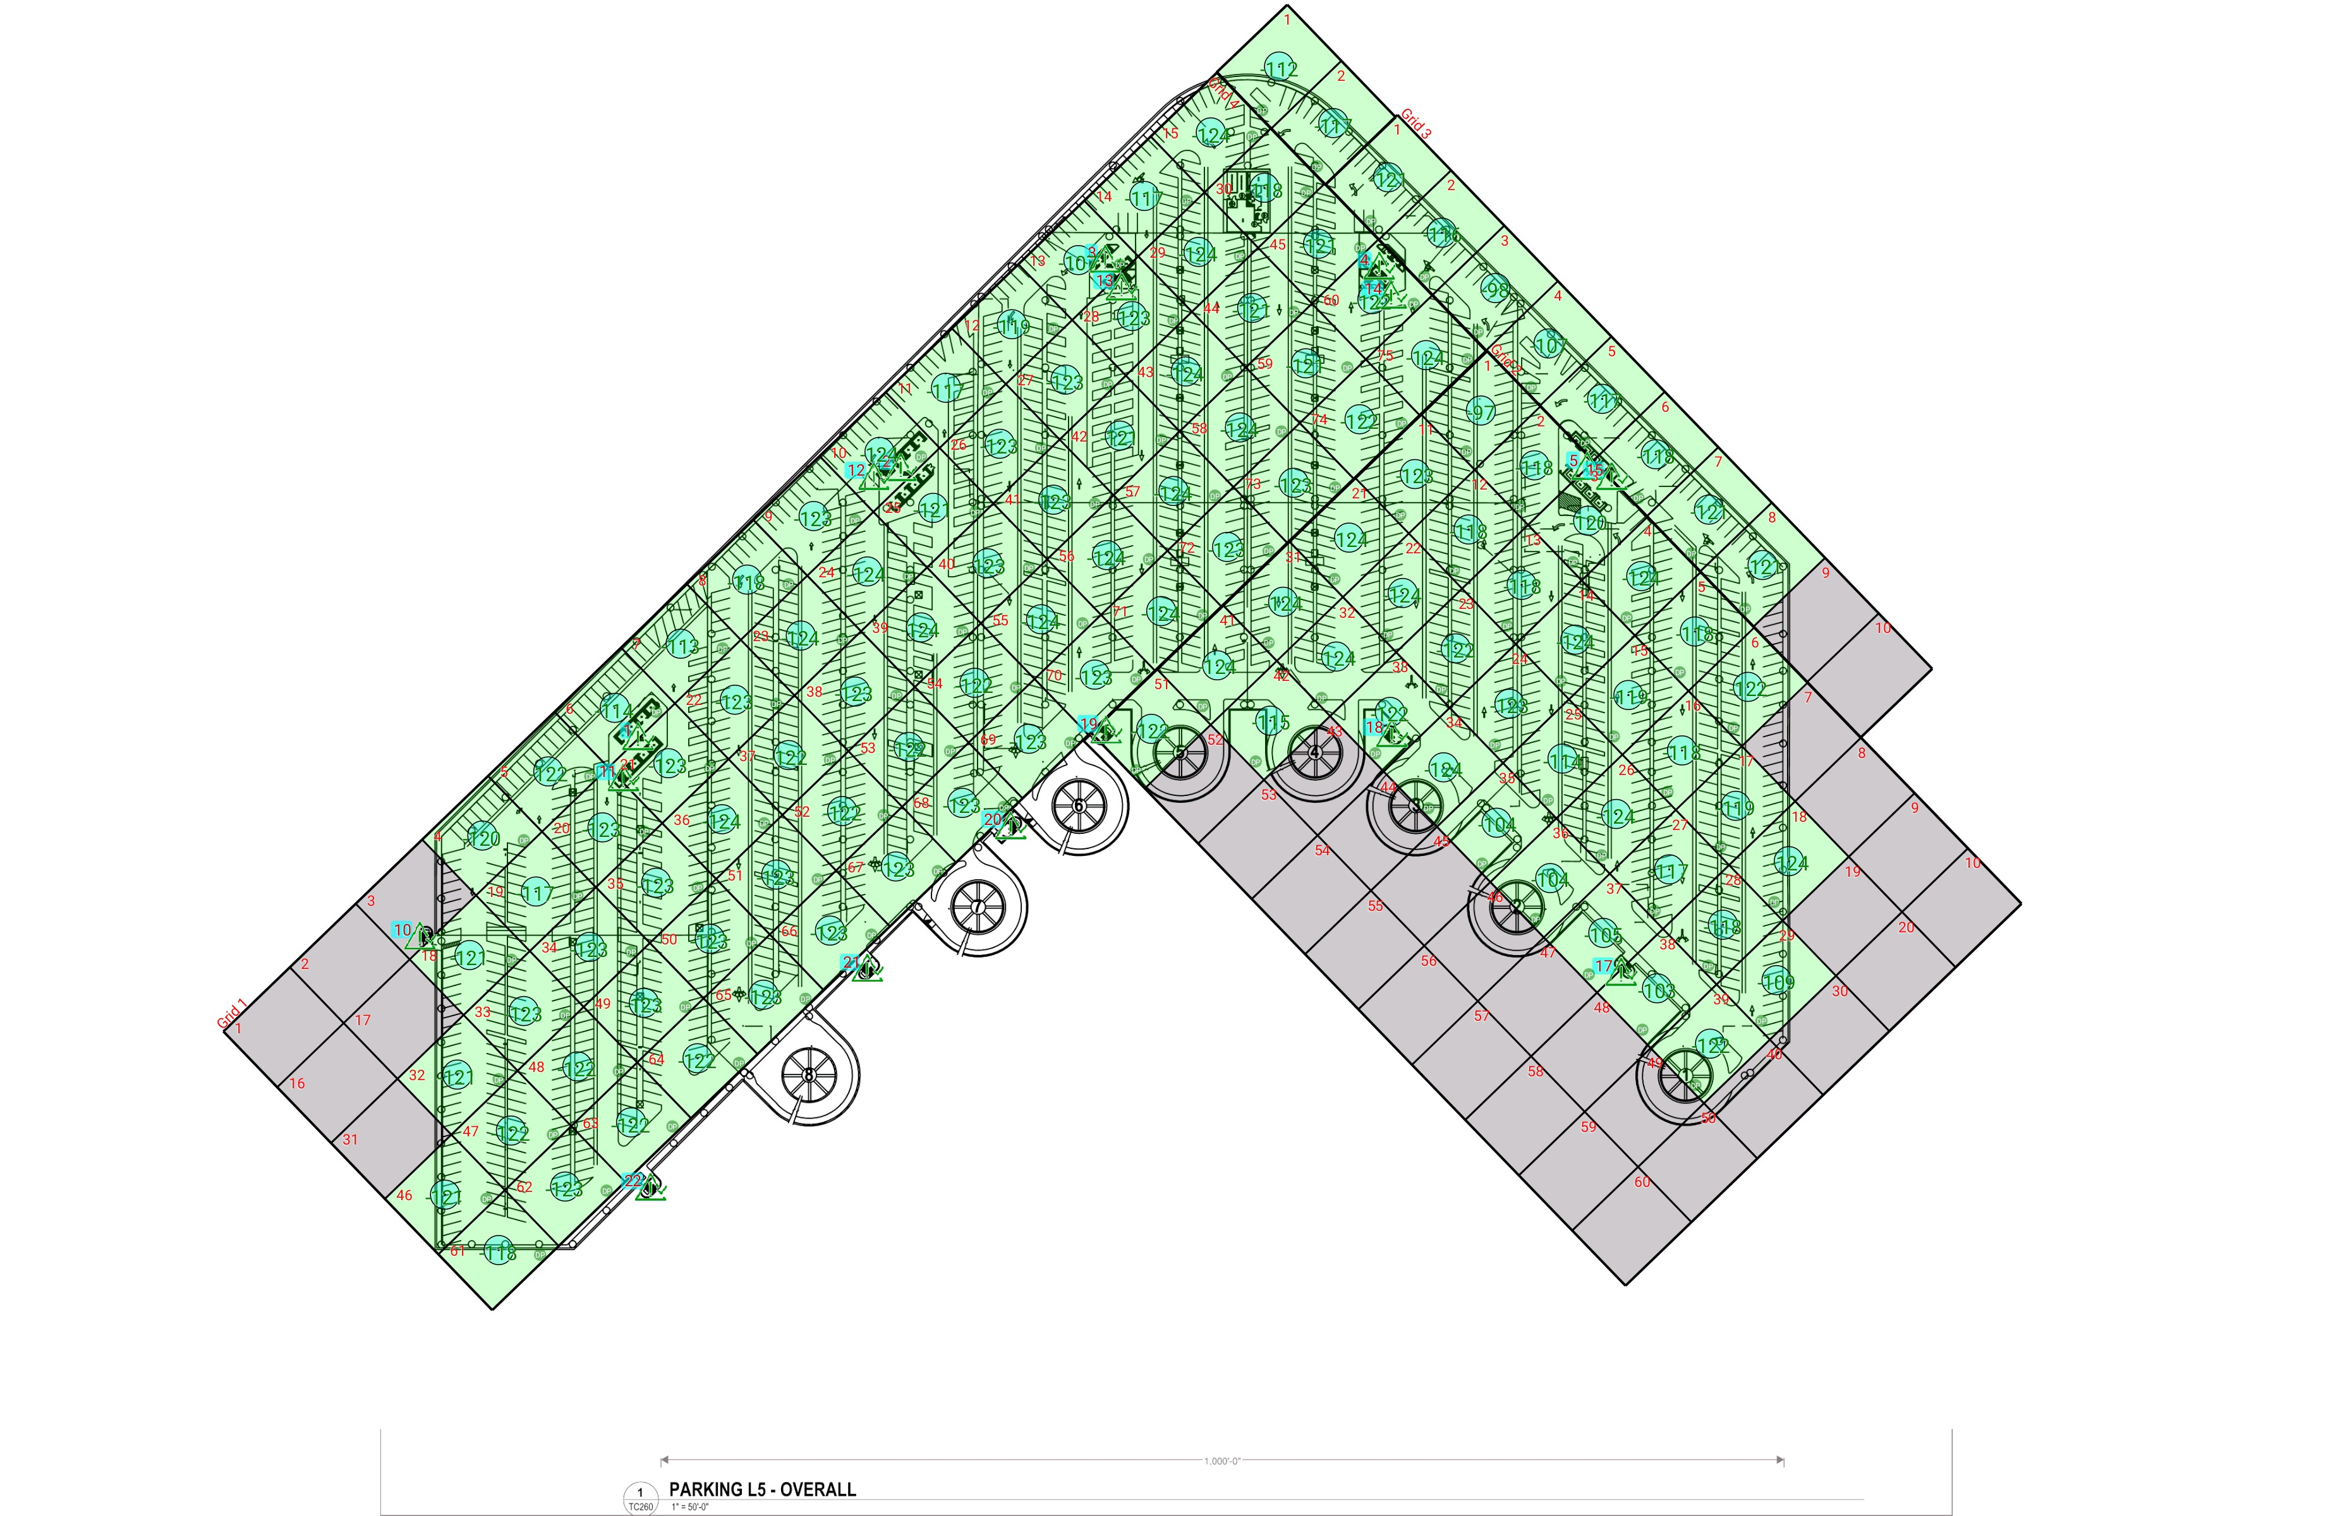

| **Grid** | **# of Areas** | **Area Size (sq. ft)** | **Area Width**  **(ft)** | **Area Height**  **(ft)** | **Ignore Area Color** | **Comments** |
| --- | --- | --- | --- | --- | --- | --- |
| 1 | 75 | 5716.71 | 82.35 | 69.42 | Black |  |
| 2 | 60 | 5654.44 | 68.75 | 82.24 | Black |  |
| 3 | 10 | 6155.31 | 68.86 | 89.39 | Black |  |
| 4 | 2 | 6139.06 | 69.91 | 87.82 | Black |  |

**Floor: Garage L5**

**Channel: 5**

| **Critical Point Report** | | | | | | | | | | | |
| --- | --- | --- | --- | --- | --- | --- | --- | --- | --- | --- | --- |
| **Critical Point** | **DL**  **Power**  **(dBm)** | **DL**  **S/N**  **(dB)** | **DL FBER (%)** | **DL**  **DAQ** | **UL**  **Power**  **(dBm)** | **UL**  **S/N**  **(dB)** | **UL FBER (%)** | **UL**  **DAQ** | **Result** | **DL**  **Loss**  **(dB)** | **Comment** |
| 1 | -121.95 |  |  |  |  |  |  |  | **Pass** |  |  |
| 2 | -120.88 |  |  |  |  |  |  |  | **Pass** |  |  |
| 3 | -119.75 |  |  |  |  |  |  |  | **Pass** |  |  |
| 4 | -121.55 |  |  |  |  |  |  |  | **Pass** |  |  |
| 5 | -121.02 |  |  |  |  |  |  |  | **Pass** |  |  |
| 10 | -118.84 |  |  |  |  |  |  |  | **Pass** |  |  |
| 11 | -122.33 |  |  |  |  |  |  |  | **Pass** |  |  |
| 12 | -121.40 |  |  |  |  |  |  |  | **Pass** |  |  |
| 13 | -123.22 |  |  |  |  |  |  |  | **Pass** |  |  |
| 14 | -122.81 |  |  |  |  |  |  |  | **Pass** |  |  |
| 15 | -118.00 |  |  |  |  |  |  |  | **Pass** |  |  |
| 17 | -108.65 |  |  |  |  |  |  |  | **Pass** |  |  |
| 18 | -121.23 |  |  |  |  |  |  |  | **Pass** |  |  |
| 19 | -122.61 |  |  |  |  |  |  |  | **Pass** |  |  |
| 20 | -122.35 |  |  |  |  |  |  |  | **Pass** |  |  |
| 21 | -121.09 |  |  |  |  |  |  |  | **Pass** |  |  |
| 22 | -121.25 |  |  |  |  |  |  |  | **Pass** |  |  |

| **Area Report** | | | | | | | | | | | | |
| --- | --- | --- | --- | --- | --- | --- | --- | --- | --- | --- | --- | --- |
| **Grid** | **Area** | **DL**  **Power**  **(dBm)** | **DL**  **S/N**  **(dB)** | **DL FBER (%)** | **DL**  **DAQ** | **UL**  **Power**  **(dBm)** | **UL**  **S/N**  **(dB)** | **UL FBER (%)** | **UL**  **DAQ** | **Result** | **DL**  **Loss**  **(dB)** | **Comment** |
| 1 | 1 | NT | NT | NT | NT | NT | NT | NT | NT | **NT** |  |  |
| 1 | 2 | NT | NT | NT | NT | NT | NT | NT | NT | **NT** |  |  |
| 1 | 3 | NT | NT | NT | NT | NT | NT | NT | NT | **NT** |  |  |
| 1 | 4 | -119.63 |  |  |  |  |  |  |  | **Pass** |  |  |
| 1 | 5 | -121.05 |  |  |  |  |  |  |  | **Pass** |  |  |
| 1 | 6 | -113.65 |  |  |  |  |  |  |  | **Pass** |  |  |
| 1 | 7 | -112.54 |  |  |  |  |  |  |  | **Pass** |  |  |
| 1 | 8 | -117.66 |  |  |  |  |  |  |  | **Pass** |  |  |
| 1 | 9 | -122.32 |  |  |  |  |  |  |  | **Pass** |  |  |
| 1 | 10 | -123.30 |  |  |  |  |  |  |  | **Pass** |  |  |
| 1 | 11 | -116.69 |  |  |  |  |  |  |  | **Pass** |  |  |
| 1 | 12 | -118.59 |  |  |  |  |  |  |  | **Pass** |  |  |
| 1 | 13 | -106.61 |  |  |  |  |  |  |  | **Pass** |  |  |
| 1 | 14 | -116.64 |  |  |  |  |  |  |  | **Pass** |  |  |
| 1 | 15 | -123.52 |  |  |  |  |  |  |  | **Pass** |  |  |
| 1 | 16 | NT | NT | NT | NT | NT | NT | NT | NT | **NT** |  |  |
| 1 | 17 | NT | NT | NT | NT | NT | NT | NT | NT | **NT** |  |  |
| 1 | 18 | -120.43 |  |  |  |  |  |  |  | **Pass** |  |  |
| 1 | 19 | -116.46 |  |  |  |  |  |  |  | **Pass** |  |  |
| 1 | 20 | -122.06 |  |  |  |  |  |  |  | **Pass** |  |  |
| 1 | 21 | -122.80 |  |  |  |  |  |  |  | **Pass** |  |  |
| 1 | 22 | -122.22 |  |  |  |  |  |  |  | **Pass** |  |  |
| 1 | 23 | -123.07 |  |  |  |  |  |  |  | **Pass** |  |  |
| 1 | 24 | -123.21 |  |  |  |  |  |  |  | **Pass** |  |  |
| 1 | 25 | -120.02 |  |  |  |  |  |  |  | **Pass** |  |  |
| 1 | 26 | -122.39 |  |  |  |  |  |  |  | **Pass** |  |  |
| 1 | 27 | -122.47 |  |  |  |  |  |  |  | **Pass** |  |  |
| 1 | 28 | -122.06 |  |  |  |  |  |  |  | **Pass** |  |  |
| 1 | 29 | -123.38 |  |  |  |  |  |  |  | **Pass** |  |  |
| 1 | 30 | -117.09 |  |  |  |  |  |  |  | **Pass** |  |  |
| 1 | 31 | NT | NT | NT | NT | NT | NT | NT | NT | **NT** |  |  |
| 1 | 32 | -120.81 |  |  |  |  |  |  |  | **Pass** |  |  |
| 1 | 33 | -122.19 |  |  |  |  |  |  |  | **Pass** |  |  |
| 1 | 34 | -122.83 |  |  |  |  |  |  |  | **Pass** |  |  |
| 1 | 35 | -122.12 |  |  |  |  |  |  |  | **Pass** |  |  |
| 1 | 36 | -123.08 |  |  |  |  |  |  |  | **Pass** |  |  |
| 1 | 37 | -121.21 |  |  |  |  |  |  |  | **Pass** |  |  |
| 1 | 38 | -122.96 |  |  |  |  |  |  |  | **Pass** |  |  |
| 1 | 39 | -123.26 |  |  |  |  |  |  |  | **Pass** |  |  |
| 1 | 40 | -122.46 |  |  |  |  |  |  |  | **Pass** |  |  |
| 1 | 41 | -122.61 |  |  |  |  |  |  |  | **Pass** |  |  |
| 1 | 42 | -120.32 |  |  |  |  |  |  |  | **Pass** |  |  |
| 1 | 43 | -123.30 |  |  |  |  |  |  |  | **Pass** |  |  |
| 1 | 44 | -120.87 |  |  |  |  |  |  |  | **Pass** |  |  |
| 1 | 45 | -120.98 |  |  |  |  |  |  |  | **Pass** |  |  |
| 1 | 46 | -120.86 |  |  |  |  |  |  |  | **Pass** |  |  |
| 1 | 47 | -121.76 |  |  |  |  |  |  |  | **Pass** |  |  |
| 1 | 48 | -121.03 |  |  |  |  |  |  |  | **Pass** |  |  |
| 1 | 49 | -122.36 |  |  |  |  |  |  |  | **Pass** |  |  |
| 1 | 50 | -122.87 |  |  |  |  |  |  |  | **Pass** |  |  |
| 1 | 51 | -122.10 |  |  |  |  |  |  |  | **Pass** |  |  |
| 1 | 52 | -121.81 |  |  |  |  |  |  |  | **Pass** |  |  |
| 1 | 53 | -121.32 |  |  |  |  |  |  |  | **Pass** |  |  |
| 1 | 54 | -121.98 |  |  |  |  |  |  |  | **Pass** |  |  |
| 1 | 55 | -123.19 |  |  |  |  |  |  |  | **Pass** |  |  |
| 1 | 56 | -123.60 |  |  |  |  |  |  |  | **Pass** |  |  |
| 1 | 57 | -123.20 |  |  |  |  |  |  |  | **Pass** |  |  |
| 1 | 58 | -123.19 |  |  |  |  |  |  |  | **Pass** |  |  |
| 1 | 59 | -120.39 |  |  |  |  |  |  |  | **Pass** |  |  |
| 1 | 60 | -121.09 |  |  |  |  |  |  |  | **Pass** |  |  |
| 1 | 61 | -117.19 |  |  |  |  |  |  |  | **Pass** |  |  |
| 1 | 62 | -122.53 |  |  |  |  |  |  |  | **Pass** |  |  |
| 1 | 63 | -121.94 |  |  |  |  |  |  |  | **Pass** |  |  |
| 1 | 64 | -121.42 |  |  |  |  |  |  |  | **Pass** |  |  |
| 1 | 65 | -122.47 |  |  |  |  |  |  |  | **Pass** |  |  |
| 1 | 66 | -122.06 |  |  |  |  |  |  |  | **Pass** |  |  |
| 1 | 67 | -122.42 |  |  |  |  |  |  |  | **Pass** |  |  |
| 1 | 68 | -122.99 |  |  |  |  |  |  |  | **Pass** |  |  |
| 1 | 69 | -122.29 |  |  |  |  |  |  |  | **Pass** |  |  |
| 1 | 70 | -122.65 |  |  |  |  |  |  |  | **Pass** |  |  |
| 1 | 71 | -123.14 |  |  |  |  |  |  |  | **Pass** |  |  |
| 1 | 72 | -122.66 |  |  |  |  |  |  |  | **Pass** |  |  |
| 1 | 73 | -122.02 |  |  |  |  |  |  |  | **Pass** |  |  |
| 1 | 74 | -121.89 |  |  |  |  |  |  |  | **Pass** |  |  |
| 1 | 75 | -123.14 |  |  |  |  |  |  |  | **Pass** |  |  |
| 2 | 1 | -96.22 |  |  |  |  |  |  |  | **Pass** |  |  |
| 2 | 2 | -118.00 |  |  |  |  |  |  |  | **Pass** |  |  |
| 2 | 3 | -119.12 |  |  |  |  |  |  |  | **Pass** |  |  |
| 2 | 4 | -123.55 |  |  |  |  |  |  |  | **Pass** |  |  |
| 2 | 5 | -118.00 |  |  |  |  |  |  |  | **Pass** |  |  |
| 2 | 6 | -121.56 |  |  |  |  |  |  |  | **Pass** |  |  |
| 2 | 7 | NT | NT | NT | NT | NT | NT | NT | NT | **NT** |  |  |
| 2 | 8 | NT | NT | NT | NT | NT | NT | NT | NT | **NT** |  |  |
| 2 | 9 | NT | NT | NT | NT | NT | NT | NT | NT | **NT** |  |  |
| 2 | 10 | NT | NT | NT | NT | NT | NT | NT | NT | **NT** |  |  |
| 2 | 11 | -122.55 |  |  |  |  |  |  |  | **Pass** |  |  |
| 2 | 12 | -118.00 |  |  |  |  |  |  |  | **Pass** |  |  |
| 2 | 13 | -117.39 |  |  |  |  |  |  |  | **Pass** |  |  |
| 2 | 14 | -123.11 |  |  |  |  |  |  |  | **Pass** |  |  |
| 2 | 15 | -118.95 |  |  |  |  |  |  |  | **Pass** |  |  |
| 2 | 16 | -118.00 |  |  |  |  |  |  |  | **Pass** |  |  |
| 2 | 17 | -118.81 |  |  |  |  |  |  |  | **Pass** |  |  |
| 2 | 18 | -123.46 |  |  |  |  |  |  |  | **Pass** |  |  |
| 2 | 19 | NT | NT | NT | NT | NT | NT | NT | NT | **NT** |  |  |
| 2 | 20 | NT | NT | NT | NT | NT | NT | NT | NT | **NT** |  |  |
| 2 | 21 | -123.36 |  |  |  |  |  |  |  | **Pass** |  |  |
| 2 | 22 | -123.28 |  |  |  |  |  |  |  | **Pass** |  |  |
| 2 | 23 | -121.47 |  |  |  |  |  |  |  | **Pass** |  |  |
| 2 | 24 | -122.10 |  |  |  |  |  |  |  | **Pass** |  |  |
| 2 | 25 | -113.53 |  |  |  |  |  |  |  | **Pass** |  |  |
| 2 | 26 | -123.89 |  |  |  |  |  |  |  | **Pass** |  |  |
| 2 | 27 | -116.48 |  |  |  |  |  |  |  | **Pass** |  |  |
| 2 | 28 | -118.00 |  |  |  |  |  |  |  | **Pass** |  |  |
| 2 | 29 | -108.43 |  |  |  |  |  |  |  | **Pass** |  |  |
| 2 | 30 | NT | NT | NT | NT | NT | NT | NT | NT | **NT** |  |  |
| 2 | 31 | -123.40 |  |  |  |  |  |  |  | **Pass** |  |  |
| 2 | 32 | -123.09 |  |  |  |  |  |  |  | **Pass** |  |  |
| 2 | 33 | -121.94 |  |  |  |  |  |  |  | **Pass** |  |  |
| 2 | 34 | -123.06 |  |  |  |  |  |  |  | **Pass** |  |  |
| 2 | 35 | -103.64 |  |  |  |  |  |  |  | **Pass** |  |  |
| 2 | 36 | -103.20 |  |  |  |  |  |  |  | **Pass** |  |  |
| 2 | 37 | -104.93 |  |  |  |  |  |  |  | **Pass** |  |  |
| 2 | 38 | -102.46 |  |  |  |  |  |  |  | **Pass** |  |  |
| 2 | 39 | -121.67 |  |  |  |  |  |  |  | **Pass** |  |  |
| 2 | 40 | NT | NT | NT | NT | NT | NT | NT | NT | **NT** |  |  |
| 2 | 41 | -123.08 |  |  |  |  |  |  |  | **Pass** |  |  |
| 2 | 42 | -114.95 |  |  |  |  |  |  |  | **Pass** |  |  |
| 2 | 43 | NT | NT | NT | NT | NT | NT | NT | NT | **NT** |  |  |
| 2 | 44 | NT | NT | NT | NT | NT | NT | NT | NT | **NT** |  |  |
| 2 | 45 | NT | NT | NT | NT | NT | NT | NT | NT | **NT** |  |  |
| 2 | 46 | NT | NT | NT | NT | NT | NT | NT | NT | **NT** |  |  |
| 2 | 47 | NT | NT | NT | NT | NT | NT | NT | NT | **NT** |  |  |
| 2 | 48 | NT | NT | NT | NT | NT | NT | NT | NT | **NT** |  |  |
| 2 | 49 | NT | NT | NT | NT | NT | NT | NT | NT | **NT** |  |  |
| 2 | 50 | NT | NT | NT | NT | NT | NT | NT | NT | **NT** |  |  |
| 2 | 51 | -121.72 |  |  |  |  |  |  |  | **Pass** |  |  |
| 2 | 52 | NT | NT | NT | NT | NT | NT | NT | NT | **NT** |  |  |
| 2 | 53 | NT | NT | NT | NT | NT | NT | NT | NT | **NT** |  |  |
| 2 | 54 | NT | NT | NT | NT | NT | NT | NT | NT | **NT** |  |  |
| 2 | 55 | NT | NT | NT | NT | NT | NT | NT | NT | **NT** |  |  |
| 2 | 56 | NT | NT | NT | NT | NT | NT | NT | NT | **NT** |  |  |
| 2 | 57 | NT | NT | NT | NT | NT | NT | NT | NT | **NT** |  |  |
| 2 | 58 | NT | NT | NT | NT | NT | NT | NT | NT | **NT** |  |  |
| 2 | 59 | NT | NT | NT | NT | NT | NT | NT | NT | **NT** |  |  |
| 2 | 60 | NT | NT | NT | NT | NT | NT | NT | NT | **NT** |  |  |
| 3 | 1 | -120.11 |  |  |  |  |  |  |  | **Pass** |  |  |
| 3 | 2 | -115.39 |  |  |  |  |  |  |  | **Pass** |  |  |
| 3 | 3 | -97.30 |  |  |  |  |  |  |  | **Pass** |  |  |
| 3 | 4 | -106.87 |  |  |  |  |  |  |  | **Pass** |  |  |
| 3 | 5 | -116.95 |  |  |  |  |  |  |  | **Pass** |  |  |
| 3 | 6 | -117.76 |  |  |  |  |  |  |  | **Pass** |  |  |
| 3 | 7 | -120.87 |  |  |  |  |  |  |  | **Pass** |  |  |
| 3 | 8 | -120.25 |  |  |  |  |  |  |  | **Pass** |  |  |
| 3 | 9 | NT | NT | NT | NT | NT | NT | NT | NT | **NT** |  |  |
| 3 | 10 | NT | NT | NT | NT | NT | NT | NT | NT | **NT** |  |  |
| 4 | 1 | -111.92 |  |  |  |  |  |  |  | **Pass** |  |  |
| 4 | 2 | -116.99 |  |  |  |  |  |  |  | **Pass** |  |  |

**Additional Info**